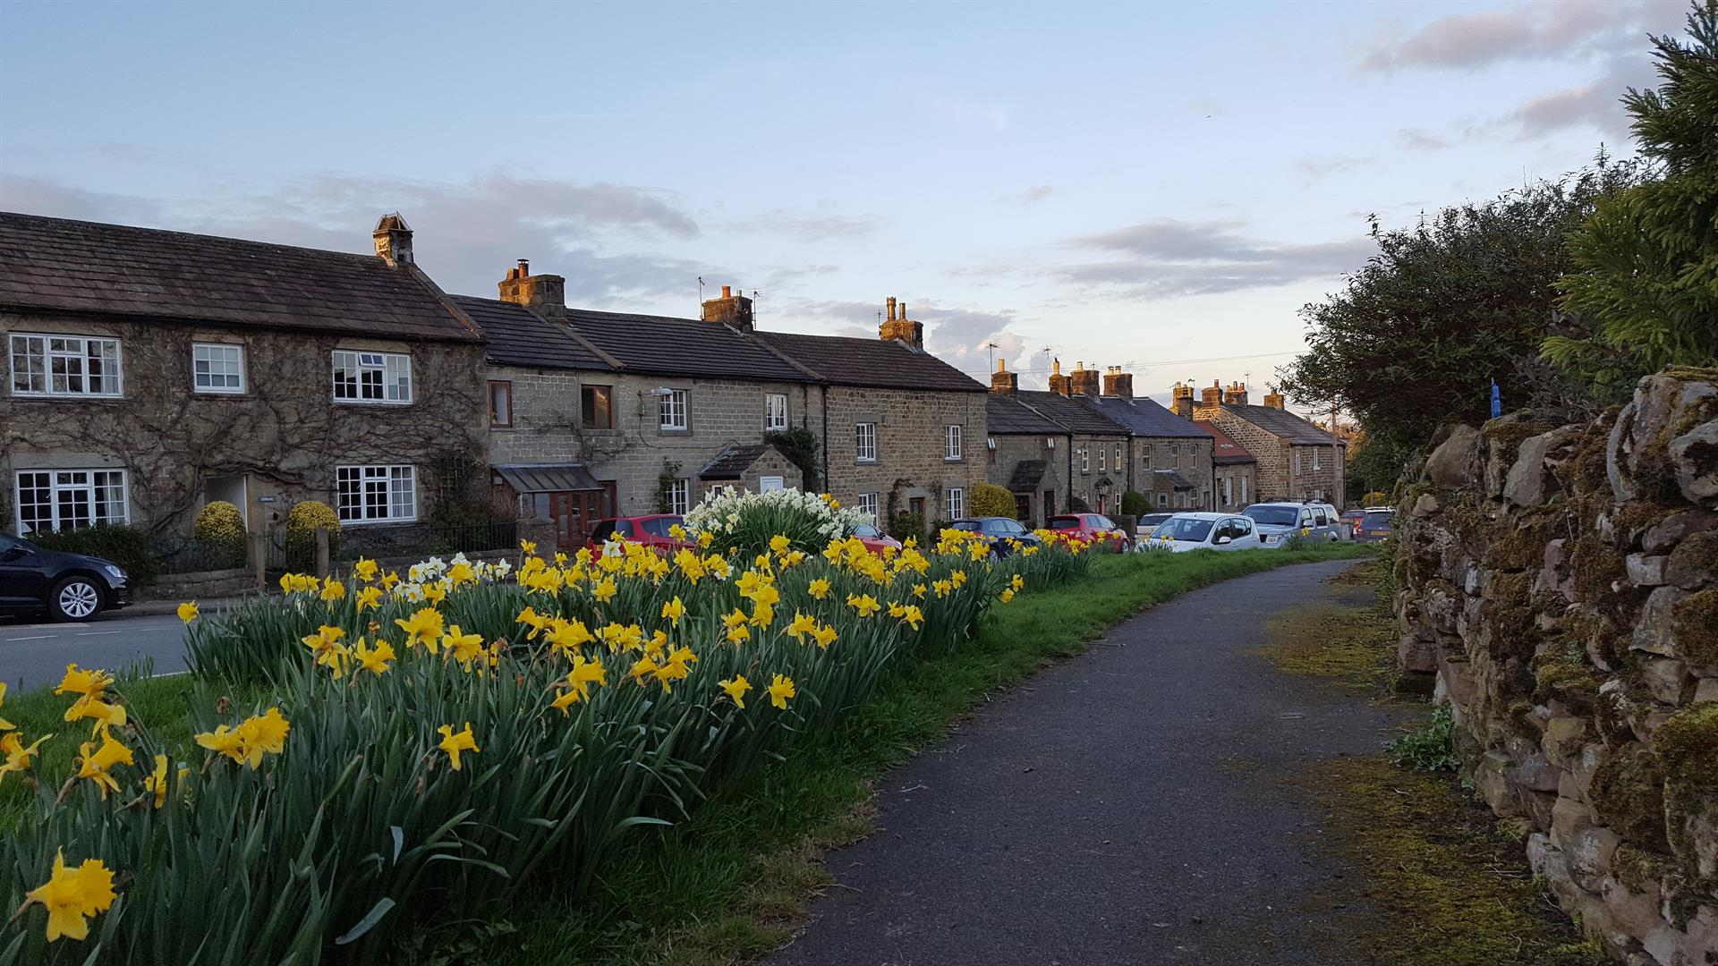
Kirkby Malzeard, Laverton and Dallowgill Neighbourhood Plan (Draft 11/2023)

Kirkby Malzeard, Laverton and Dallowgill Grouped Parish Council

CONTENTS
SECTION 1 - INTRODUCTION
Foreword
Introduction 1.1 – 1.3
Background 1.4 – 1.8
Neighbourhood Plan Area 1.9
Why we decided to prepare a Neighbourhood Plan 1.10 –1.13
How the Plan was prepared 1.14 – 1.17
How the Plan is organised 1.18

SECTION 2 – THE PLANNING POLICY CONTEXT
The Planning Policy Context 2.1 – 2.20

SECTION 3 – THE PARISH
An Introduction to the Parish
The Parish Past 3.1 - 3.6
The Parish Present 3.7 – 3.21

SECTION 4 – VISION AND OBJECTIVES
Vision
Objectives 4.1 – 4.4

SECTION 5.1 - HOUSING
Housing 5.1.1
Supporting sustainable housing growth 5.1.2 – 5.1.13
Policy KMLD1 – Kirkby Malzeard Development Limits 5.1.8
Windfall sites 5.1.14 – 5.1.19
Housing Mix 5.1.20 – 5.1.26
Policy KMLD2 – Housing Mix 5.1.26
Affordable Housing 5.1.27 – 5.1.33
Parish Action 1 - Affordable Housing Provision 5.1.33
Meeting the essential housing needs of rural workers 5.1.34 – 5.1.36
Policy KMLD3 – Properties with agricultural occupancy restrictions 5.1.36
Conversion of redundant agricultural buildings 5.1.37 – 5.1.38
Policy KMLD4 – Re-using redundant agricultural buildings 5.1.38
Second homes and holiday lets 5.1.39 – 5.1.43

SECTION 5.2 - BUILT HERITAGE
Built Heritage 5.2.1 – 5.2.4
Buildings of national heritage importance 5.2.5 – 5.2.9
Non-designated heritage assets 5.2.10 – 5.2.17
Policy KMLD5 – Non-designated heritage assets 5.2.17
Local area of special character and heritage 5.2.18 – 5.2.21
Policy KMLD6 – Church Street, Kirkby Malzeard local area of
special character and heritage 5.2.21
Ensuring good design 5.2.22 – 5.2.25
Policy KMLD7 – Ensuring high quality design 5.2.25

SECTION 5.3 – NATURAL ENVIRONMENT
Conserving and enhancing the landscape 5.3.1 – 5.3.9
Protecting important local green spaces 5.3.10 – 5.3.17
Policy KMLD8 – Local green spaces 5.3.17
Allotments and community garden 5.3.18 – 5.3.23
Parish Action 2 – Additional allotment/community garden
provision in Kirkby Malzeard 5.2.23
Conserving dark skies 5.3.24 – 5.3.30
Policy KMLD9 – Conserving dark skies 5.3.30
Protecting and enhancing biodiversity 5.3.31 – 5.3.43
Policy KMLD10 – Protecting and enhancing biodiversity 5.3.43
Protecting and enhancing trees, hedgerows
and woodlands 5.3.44 – 5.3.54
Parish Action 3 – Tree preservation orders 5.3.53

SECTION 5.4 - COMMUNITY FACILITIES
Protecting and enhancing community facilities 5.4.1 – 5.4.11
Policy KMLD11 – Enhancing the provision of important
community facilities 5.4.11
Assets of community value 5.4.12 – 5.4.15
Policy KMLD12 – Assets of community value 5.4.15

SECTION 5.5 – INFRASTRUCTURE
Highway safety 5.5.1 – 5.5.6
Policy KMLD13 – Promoting highway safety 5.5.6
Parish Action 4 – Highway safety 5.5.6
Car parking in Kirkby Malzeard 5.5.7 – 5.5.10
Policy KMLD14 – Car parking in Kirkby Malzeard 5.5.9
Parish Action 5 - Provision of public car park in Kirkby Malzeard 5.5.10
Public transport 5.5.11 – 5.5.16
Parish Action 6 – Local bus services 5.5.16
Ultra-low emissionsvehicle infrastructure 5.5.17 – 5.5.22
Policy KMLD15 – Ultra-low emissionsvehicle infrastructure 5.5.22
Public access routes 5.5.23 – 5.5.27
Parish Action 7 – public access routes 5.5.27
Utilities 5.5.28 – 5.5.32
Parish Action 8 – Utilities 5.5.32

SECTION 6 – MONITORING AND REVIEW
Monitoring and review 5.6.1 – 5.6.2

APPENDICES:
APPENDIX A – Non-designated Heritage Assets
APPENDIX B - Church Street Special Character Area
APPENDIX C – Local Green Spaces

