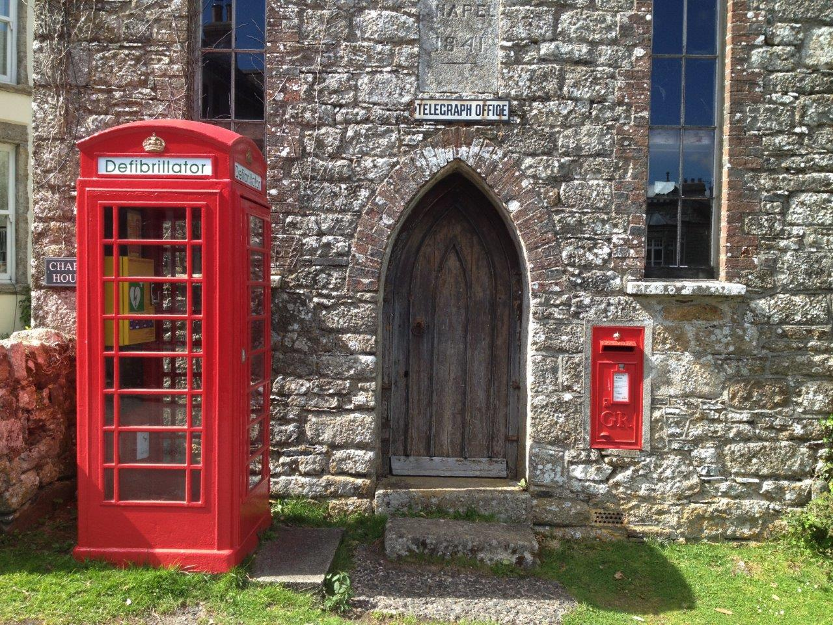

The below information is supplied by BT solely as a reference document and does not form part of any agreement regarding transfer of ownership of a kiosk from BT.
It is strongly recommended that for any painting, structural repairs or inspections of the Kiosk, work should be carried out by companies who are experienced in working with these structures. This information is provided as reference material only and the information contained within is subject to change without notice.
THE K SERIES KIOSK
K6 kiosks are the familiar red cast iron structures that have been operational since the 1930's. The kiosks are constructed from a number of individual castings made from cast iron, interconnected by mild steel threaded fixings. The door comprises of a wooden framework with a cast iron or aluminium glazing frame. These require regular painting and inspection.
SAFETY CONSIDERATIONS AND PRECAUTIONS
LEAD PAINT PRECAUTIONS
The possibility of previous coated organic and inorganic lead paint may exist on a red payphone Kiosk and all relevant health and safety aspects and legislation should be considered and implemented for dealing with such hazards.

Fume or dust from lead or lead compounds can be absorbed by inhalation or ingestion and sometimes through the skin. Excessive absorption, evidenced by high lead content in the blood, leads to lead poisoning.

All waste should be disposed of ensuring that it complies with the current Environmental Protection Act waste disposal policy.

PAINT SELECTION

Suppliers of Industrial Paints that have supplied paint to BT are: -

- Trimite Ltd, Arundel Road, Uxbridge, Middlesex, UB8 2SD

- Joseph Masons, Nottingham Road, Derby, DE2 6AR

- International Paint, Stoneygate Lane, Felling, Gateshead, Tyne & Wear NE 10 0JY

All paint should be applied in accordance with the manufacturer instructions.
Alternative suppliers of paints may be acceptable.

PAINTING

The primer for repainting housings should be a universal primer for wood and metal.

All internal & external surfaces to be painted should be primed, clean and dry. No painting should be undertaken when surfaces are damp.

All bare wood or metal surfaces shall have had a minimum of one prime.

The primer should be brush applied. No paint should be applied to the door hinges or closer arm joints. The primer and paint should be applied in accordance with the manufacturer’s instructions.

External quality fillers should be used as required. Fillers used should be single pack Polyester or Epoxy Resins and compatible with the paint system. The appropriate safety precautions as indicated by the Manufacturer should be complied with.

It is recommended that two coats of finish paint should be applied.

White colour paint is recommended inside the kiosk within the ceiling area down to the level of the ventilation openings and a clean horizontal break line should be applied.

Black colour paint should be applied to the external base of the Kiosk if it is already coloured black.

British Standard Colour References for Paints used previously by BT

Currant Red BS381C – 539C | Black BS4800 - 00-E-53
White BS4800 – 00-E-55 | Gold BS4800
Green BS4800 | Grey BS4800
KIOSK STRUCTURE
The structure of the K6 Kiosk should be examined for cracks and breaks, if damage is found an experienced kiosk repair company should be immediately employed to remedy the damage.

GLAZING
Glazing replacement should be toughened glass, certified to BS 6262.

The glass should be bedded in clear silicon mastic, a minimum thickness to glazing bars being employed so as to minimise excess mastic being visible. K6 standard glazing frames should be used to retain the glass with the accompanying rivets and washers to secure the frames.

Glass door Push / Pull should be fitted adjacent to the handle position in the correct orientation.

`TELEPHONE' glass mounted in the kiosk transom positions should also be bedded in clear silicon mastic. A fixing finish of clear silicon mastic, smoothed to a neat bevel from the glass/polycarbonate to the frame should then be applied to secure the glass in place.
KIOSK DOOR / HINGES
The Kiosk door is made of a hard wood construction, these need to be inspected to establish whether the door is in sound and safe condition. The door should be inspected to ensure it is free from rot, that joints and rails are sound and free from significant damage, and that the door is free from warping. The strap hinges and fixings should also be inspected for any damage or excessive wear.
If the door or hinges are found not to be in a good condition, they should be removed and replaced.

ELECTRICAL PRECAUTIONS
A competent and suitably qualified person should carry out any electrical works in the first instance. After any electrical works has been completed an electrical test should be carried out and a certificate issued showing conformance and compliance. A scheduled electrical maintenance plan should then be adopted to ensure regular compliance and certification for the life of the kiosk.

BT SUPPLIERS

There are a number of companies in operation that carry spare parts for these kiosks and can carry out refurbishments, however, our suppliers are:

www.x2connect.com

Similarly BT has used the following company to carry out painting and various repairs in the past.

http://www.mitie.co.uk/

While BT does NOT recommend or vouch for the work or products of any particular company listed above for any repairs or parts, it will be necessary to approach a specialist company to ensure that correct parts are provided. Any of the above listed companies will be able to assist while alternative companies and suppliers can also be sourced.
The following is a list of the various component parts found in a K6 series kiosk and may be of use as reference.

.
K6 ROOF TELEPHONE SIGN | K6 POWER GUARD WASHER + SCREW M8
K6 ROOF LIGHT COMPLETE | K6 POWER GUARD PLASTIC
K6 ROOF LIGHT INTERFACE | K6 ELECTRIC’S BOARD
K6 ROOF SIGN | K6 SERVICE CHAMBER
K6 GLAZING FRAME LARGE | K6 FACIA PANEL BLACK CASH
K6 GLAZING FRAME SMALL | K6 SPACEFRAME MECH PANEL
K6 GLASS WINDOW LARGE | K6 FACIA PANEL BLACK CARD
K6 GLASS WINDOW SMALL | K6 BACK COMPLETE
K6 WINDOW RIVETS | K6 DOOR CLOSER
K6 DOOR HANDLE | K6 DOOR CLOSER ARM KIT
K6 DOOR HINGE | K6 GLASS DOOR PUSH/PULL
K6 DOOR SHACKLE PLATE | K6 DOOR LH GLASS
K6 DOOR SHACKLE PIN | K6 DOOR RH GLASS
K6 DOOR STRAP SHACKLE | K6 DOOR
K6 DOOR STRAP | K6 COVER LINE AND EARTH
Listed kiosk information
In the event that the K series kiosk is listed there are responsibilities attached to the ownership of a listed building which must be adhered too. This can stipulate the colour, component type and materials used, also any physical repositioning of a kiosk.

Further information can be obtained from,

English Heritage
Customer Services Department
PO Box 569
Swindon
SN2 2YP
England,
http://www.english-heritage.org.uk/server/show/nav.2

Cadw
Welsh Assembly Government
Plas Carew
Unit 5/7 Cefn Coed
Parc Nantgarw
Cardiff
CF15 7QQ
http://www.cadw.wales.gov.uk/default.asp

Historic Scotland
Longmore House
Salisbury Place
Edinburgh
EH9 1 SH
http://www.historic-scotland.gov.uk/index.htm
The Department of Local Government and communities publishes guidance for planning authorities and owners of listed buildings. Planning and Policy Guide (PPG) 15 contains the current guidance. It is available at http://www.communities.gov.uk/planningandbuilding/planning/planningpolicyguidance/planningpolicystatements/planningpolicyguidance/

