The seahorse
One sunny Monday a girl named Felicity was at a beach near Scarborough. Felicity had a mint choc chip ice cream and her sister Gwendoline had a choc melt ice cream. Gwendoline had two very neat short plaits hanging down above her little shoulders, she also had a cute fringe on top of her wrinkly forehead.
Felicity had hair down to her bottom in a high ponytail.
Felicity had a little dog with her called Millie, Millie had beautiful black fur and they had a little brown one.


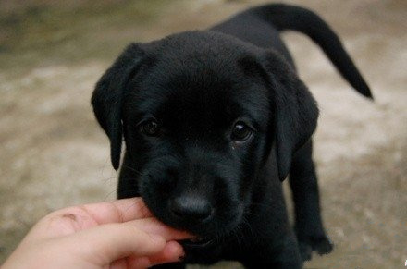
Felicity loves taking Millie and Rosie to the beach for a walk. Felicity was 10 and Gwendoline was 11 and they usually went to the beach to take the dogs for a walk. suddenly Felicity
noticed a surfer in the water who looked very upset.



Felicity took out her ponytail and let her hair sway about. She put on her bikini and jumped in the water when she finally got to the surfer she said "hey what's wrong I heard you weeping and I've been wondering what's up."
"Ok I'll tell you but you can't tell any one a single bit of my story, it's just that if you can see that…." said the surfer as he pointed. "What is it? I can't tell what it is" said Felicity. "Oh really really really I know what it is and, well it's a seahorse". "Where in the world did the name seahorse come from?" "Well of course god named that animal (he pointed at the seahorse) and that means that it is a real thing". "we should save it because it would be a kind thing to do. Please we need to do it". "no you do it, not me". "why?" "because I can not swim I have never been able to." "so why are you a surfer?" said Felicity "well a bully named Roy said if I don't become a surfer he would kill me and I suppose I will die any way because if I fall I will die!" Felicity jumped in the water and scooped up the seahorse and put her on land and gave her cpr. Felicity gently lifted her up and saw her blink, she was not dead, Felicity put her back in the water and said "good luck." Felicity got out her bikini and went to Gwendoline. Soon after Felicity saved the seahorse, Felicity and Gwendoline went home. Felicity loved telling her parents about saving the seahorse but her parents did not believe her. But at least Felicity knew that it was true. On Friday Felicity looked in the post box and saw the magazine she had been waiting for, she popped it in her orange school bag and she called to her mum "I'm off to school". Felicity walked to school and she met her bff (best friend forever!) Dolly and showed Dolly her news paper and read the title "the seahorse" to her. Dolly was super impressed with her title and so they read on. Soon after that Felicity had become famous of her seahorse life saving and her mum and dad were so proud.

