Section 5.3: Natural Environment

Conserving and Enhancing the Landscape

1. The parish is set within the lovely and undulating countryside of Lower Nidderdale. About half of the total land area of the Parish is open heather moorland. The rest is mainly upland small scale livestock farms, forming a patchwork of fields bounded by drystone walls. The steep wooded valleys of Dallowgill and Carlesmoor hold a mix of ancient oak woodland and more recent conifer plantations, which are slowly being replaced by new mixed broadleaf plantations.

- For many residents and visitors alike, this diverse and interesting landscape makes the Parish special and distinctive. The beautiful setting of the parish provides for formal and informal recreational opportunities (walking, cycling and horse riding are popular pastimes), offers tranquillity, nurtures a richness of wildlife, and offers stunning views.

- The quality and importance of this landscape are demonstrated in the findings of community consultation as well as other important studies. The Kirkby Malzeard and Grewelthorpe Landscape Character Assessment Area 35 (see below) described the landscape as ‘beautiful, interesting and well-tended’ just to name one example.

- That the landscape is of high value is reflected in that the whole of the Parish is within the Nidderdale Area of Outstanding Natural Beauty (‘Nidderdale AONB’). This means that the distinctive character, natural beauty and cultural heritage are so outstanding that it is in the nation’s interest to conserve them. The Nidderdale AONB received its protected status in 1994. Within AONBs there are additional and strict planning controls over the type of development which can take place. This acts as a major constraint on new development. More information about the Nidderdale AONB can be found at https://nidderdaleaonb.org.uk/.

- The consultation shows that the designation of the whole of the parish as part of the Nidderdale AONB is recognised and supported by the community. It is an important planning tool in conserving the distinctive character of Nidderdale, focusing development on more sustainable locations, while providing opportunities for recreation and leisure close to where people live. The area has many important assets including sites of nature conservation value. The Plan fully supports the continued designation of the whole of the parish as an AONB and urges that the additional planning controls and provisions this designation brings be assertively applied.

- In 2004 the Local Planning Authority undertook a detailed assessment of this landscape. Known as a Landscape Character Assessment (LCA) this is a standard system for identifying, describing, classifying and mapping the landscape. It helps explain the unique combination of elements and features that make landscapes distinctive by mapping and describing character types and areas. It identified 100 distinct landscape character areas in Harrogate district.

- The parish is covered by four Landscape Character Areas (Laverton Upland Fringe; Skelding Moor, Galphay Moor and Lumley Moor Upland Fringe Farmland; Kirkby Malzeard Parliamentary Enclosure; and Kirkby Malzeard and Grewelthorpe Area). These are summarised below. Further information including full descriptions for each one and maps can be found at https://www.northyorks.gov.uk/planning-and-conservation/heritage-conservation-areas-and-listed-buildings/heritage-conservation-areas-and-listed-buildings-harrogate/landscape-character-assessment/landscape-character-assessment-quadrants

Area 9 – Laverton Upland Fringe

Key characteristics:
- ‘Millstone grit solid geology’.
- ‘Landform is undulating from 280m to 150m AOD (Above Ordnance Datum) gradually falling away to the east from the high moorland plateau to the west’.
- ‘Small, random grassland fields are examples of early enclosure, possibly medieval’.
- ‘Field boundaries are dry stone walls’.
- ‘Traditional building materials are local gritstone with stone slate and blue slate roofs’.
- ‘The field systems, earthworks and disused quarries are all of historic importance’.

Sensitivities and pressures:
- ‘This distinct rural Character Area, with a long-established historic pattern, is sensitive to changes that development and changing land management regimes could bring’.
- ‘Distinctiveness will be lost if insensitive development is permitted’.
- ‘Access to the area is via a limited network of minor roads that wind along the sloping landform except at the moorland edge where the road becomes straight’.
- ‘Neglect of field boundaries has resulted in the amalgamation of fields and a simplification of field pattern’.
- ‘Woodland management, possible neglect of Ancient Semi-Natural woodland and extension of conifer plantations’.
- ‘Neglect of heritage features resulting in their degradation’.
- ‘Neglect and degradation of the footpath network, which provides clues to the historic and cultural origins of the area, is detrimental’.

Area 32 - Skelding Moor, Galphay Moor and Lumley Moor Upland Fringe Farmland

Key characteristics:
- ‘Solid geology of Millstone grit and coal measures and some drift geology of till’.
- ‘Landform is generally flat to gently rolling between 260m AOD in the west adjacent to the open moorland to 150m AOD in the east adjacent to the River Laver corridor’.
- ‘Improved and semi-improved grassland for intensive livestock production in medium-sized rectangular fields bounded by hedges or walls and typical of parliamentary enclosure. There are a few small and medium-sized woodland blocks, including one block of Ancient Semi-Natural woodland at Foster Field, as well as several conifer plantations’.
- ‘There are several scattered farmsteads in the area. Evidence of old settlement, possibly prehistoric, at Cast Hills on the western edge of the area. Disused mine workings at Skelding Moor and several small disused quarries’.

Sensitivities and pressures:
- ‘The regular pattern created by the parliamentary enclosure fields and the relative openness of this area in combination with the sparse and scattered distribution of farmsteads and houses make it sensitive to change as a result of development’.
- ‘Conifer forestry has had a considerable, and detrimental, impact on character. Their stark, dark green plantation boundaries, often viewed against the skyline, have no regard to landform and are incongruous among the muted greens and greys of the fields, walls, buildings and hedges’.
- ‘Changing fortunes of farming has resulted in deterioration of drystone walls and use of post and wire fencing for stock proofing’.
- ‘Individual trees in the landscape are of a similar age’.
- ‘Deterioration in water quality would impact upon the wildlife value of Lumley Moor Reservoir and adjacent land resulting in a change of character’.
- ‘Unimproved grassland in the area may come under threat from changing farming practices due to economic pressures on landowners’.

Area 34 – Kirkby Malzeard Parliamentary Enclosure.

Key characteristics:
- ‘Millstone grit solid geology overlain with till drift geology’.
- ‘Undulating landform sloping between 170m and 280m’.
- ‘Medium sized fields are typical of parliamentary enclosure (rectangular) bound by stone walls. Woodland cover is of small mixed and conifer plantations’.
- ‘There are no major settlements and few scattered farmsteads of moderate size. Building materials include gritstone, stone slate and red tile roofs’.

Sensitivities and pressures:
- ‘The field pattern is an important characteristic that is sensitive to change through neglect of stone wall boundaries’.
- ‘The few farmsteads in the area probably date back to the time of the Parliamentary Enclosure Acts. Their character and contribution to the landscape has been impacted upon by the introduction of modern farm buildings’.
- ‘The stark contrast at the western end of the area between the darkness of the gritstone moor and bright green of the improved grass fields indicates the limited diversity of habitats’.
- ‘The dark green of rectilinear conifer plantations is a dominant element, not in harmony with the area’s character. These plantations have the greatest impact at the upland edge where they border both the open moorland and the parliamentary enclosure grassland’.
- ‘Agricultural policy and changes in the fortunes of agricultural businesses are likely to be the main forces for change in this area’.

Area 35 – Kirkby Malzeard and Grewelthorpe Area

Key characteristics:
- ‘Millstone grit solid geology overlain with till drift geology’.
- ‘Undulating landform’.
- ‘Numerous springs and wells’.
- ‘Tree cover is of deciduous clumps of woodland plus lots of individual trees scattered along field boundaries (sycamore and ash dominate)’.
- ‘Traditional building materials are gritstone and stone slate roofs’.

Sensitivities and pressures:
- ‘The loss of distinct, linear field boundaries due to amalgamation has impacted upon the historic fabric of the landscape. However, the strong, long, thin field systems are still apparent in places around and between the villages’.
- ‘The area is sensitive to further loss of field boundaries through neglect and amalgamation. The loss of hedgerows and hedgerow trees would open out the landscape changing its character’.
- ‘The settings of the villages are sensitive to change, which may result from development such as extensions to domestic curtilage and new building’.
- ‘The main pressures that come to bear in this area are related to the changing fortunes of the farming industry resulting in diversification and conversion of traditional farm buildings’.

- The Plan strongly supports maintaining all aspects of the special character of the landscape of the Parish; moorland, farmland with drystone walls, native woodland, and buildings using traditional materials in keeping with the landscape.

- The Plan did consider having its own landscape policy but concluded that this was not necessary as would duplicate both the existing policies in the Local Plan and AONB guidance, in particular, Policy GS6: Nidderdale Area of Outstanding Natural Beauty (AONB), which states that ‘The natural beauty and special qualities of the Nidderdale Area of Outstanding Natural Beauty (AONB) will be conserved and enhanced’.

Protecting Important Local Green Spaces

- There are numerous green spaces to be found in Kirkby Malzeard and beyond. These include play areas, sport pitches, green spaces within housing areas, churchyards and verges.

- These green spaces are highly valued by the community. Access to good green spaces close to where people live is important to health and wellbeing. In the community survey when asked at question 14 ‘Do you feel that additional controls should be included in the Neighbourhood Plan and if so which are the priorities? – tick all boxes you consider important’, 293 or 71% of respondents mentioned ‘Identify and protect local green spaces used by the community’.

- It is essential, therefore, that important green spaces in the built-up parts of the parish are fully protected from inappropriate development and where possible enhanced. This will ensure that the community has access to quality open spaces near to where they live for sport and recreational purposes as well as protecting spaces that are important to the character of the area.

- These green spaces have varying degrees of protection through various Local Plan policies including Policy HP6: Protection of Existing Sport, Open Space and Recreation Facilities.

- National and local planning policy allows, through neighbourhood plans, the opportunity for communities to identify and give special protection to green areas of particular importance to them by designating them as local green spaces. Where land is designated as a Local Green Space, it is protected from development other than in very special circumstances.

- To be designated as Local Green Space, however, it must meet specified criteria as set out in the National Planning Policy Framework. These include that it is:
- In reasonably close proximity to the community it serves;
- demonstrably special to a local community and holds a particular local significance, for example, because of its beauty, historic significance, recreational value (including as a playing field), tranquillity or richness of its wildlife; and
- local in character and is not an extensive tract of land.

- The many green spaces in the built-up parts of the parish were evaluated for their suitability for Local Green Space designation by the Steering Group. After careful consideration, six green spaces were identified that are considered to have the greatest importance and meet the criteria for designation.

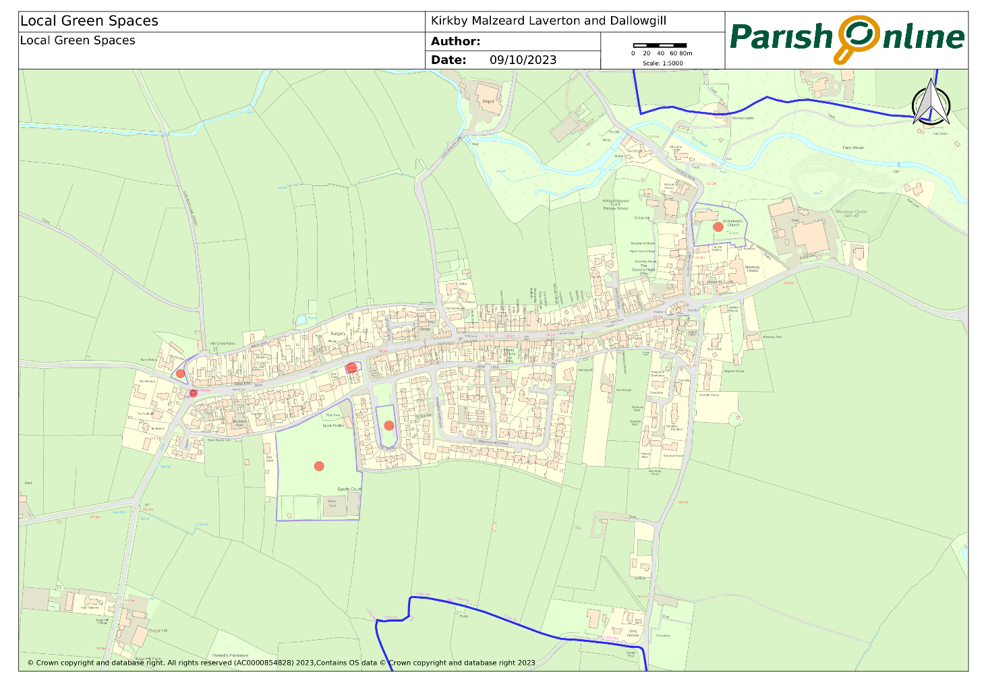

- Further information about the sites that qualified under the criteria is outlined in Appendix C, with justification in the accompanying Local Green Spaces Report which forms part of the evidence base.

POLICY KLMD8: LOCAL GREEN SPACES.
The sites identified below, and as identified on the proposals map, are designated as Local Green Spaces.
- Highside Playing Fields, Back Lane South, Kirkby Malzeard.
- Jubilee Garden, Main Street, Kirkby Malzeard.
- West End Green, Back Lane North/Ringbeck Road, Kirkby Malzeard
- ‘Island’ of greenspace at the junction of Back Lane North, Ringbeck Road and Main Street, Kirkby Malzeard.
- The Green, Kirkby Malzeard (excluding the section which may be considered for public car park - see Parish Action 5).
- Churchyard surrounding, St Andrew’s Church, Church Street, Kirkby Malzeard.

Development will not be permitted within a designated Local Green Space, unless there are very special circumstances where the public benefits of the development proposed would outweigh the harm that would be caused by development within the Local Green Space.

Allotments and Community Garden

- Allotments and Community Gardens provide a wide range of benefits to communities and the environment and are important for several reasons. These include providing sustainable and low-cost food production; giving a healthy activity for people; fostering community development and social contact and supporting wildlife.

- There is one small allotment site in the parish within ‘the Pinfold’ on Main Street, Kirkby Malzeard. This has been in continued use for many years. Some residents rent allotments in neighbouring parishes.

- Community consultation suggests that many residents would be interested in renting an allotment if there were some conveniently located in the parish. Parish councils have a legal duty to seek to provide allotments when there is sufficient demand.

- The Parish Council has been seeking suitable land for an allotment site. A site of 0.4 ha would be suitable to accommodate 20 ‘half plots’ and associated paths and parking.

- The Parish Council has identified a site to the north of Main Street in Kirkby Malzeard (see map below), which may be suitable for an allotment site. It is working with the landowners, the Local Planning Authority and other interested parties and individuals to bring it forward. If this site is not feasible it will continue to identify and bring forward another suitable site in Kirkby Malzeard.

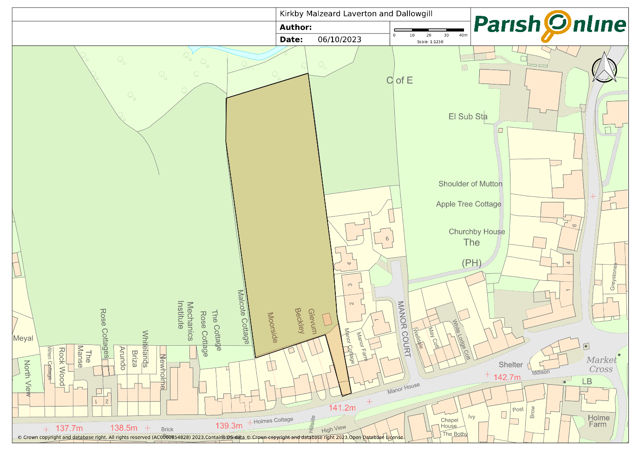

- It should be noted that generally, developing an allotment site does not require planning permission but often the associated buildings e.g. fences, sheds, vehicular access etc. do.

PARISH ACTION 2: ADDITIONAL ALLOTMENT/COMMUNITY GARDEN PROVISION IN KIRKBY MALZEARD
The Parish Council will work in partnership with the Local Planning Authority, local landowners and other interested parties to identify and bring forward an allotment site in or on the edge of Kirkby Malzeard.

Conserving Dark Night Skies

- Darkness at night is one of the key characteristics of rural areas and a feature that national policy seeks to protect. The NPPF (para. 185) notes that in seeking to protect and enhance the natural environment, planning policies should ‘limit the impact of light pollution from artificial light on local amenity, intrinsically dark landscapes and nature conservation’.

- The intrinsically dark skies, that are a result of the rural nature of the parish, is one of the main things that sets it apart from more urbanised areas. As the Nidderdale AONB website states, ‘The dark sky above Nidderdale AONB is one of the most beautiful and darkest in the country. Not many places are truly dark anymore and this is one of the things that makes this area such a special place’. Indeed, one of the objectives (L1:4) of the Nidderdale AONB Management Plan (2019 – 2024) is to secure International Dark Sky Reserve status for Nidderdale AONB, together with the Yorkshire Dales National Park Authority, reflecting the international importance of and the need to protect the dark skies above it. The achievement of this status is something the Plan supports. The findings from community consultation underlined that many respondents consider that preserving dark skies should be a priority for the Plan.

- The Council for the Preservation of Rural England (CPRE) ‘night blight map’ illustrates that the parish is an area of relatively dark skies. It forms part of a band to the west of North Yorkshire which exhibits some of the darkest skies in Yorkshire and England more generally.

- These dark skies are also important for the local wildlife. This includes several species of ‘light-sensitive’ bat and owl, as well as species of ‘light-sensitive’ moths that have been recorded across the parish. Light pollution can interrupt the natural rhythms of wildlife including migration, reproduction and feeding patterns. According to the International Dark-Sky Association, glare from artificial lights can have the following impacts:
- Wetland habitats – disruption of the nocturnal activity of amphibians whose night time croaking is part of the breeding ritual, interfering with reproduction and reducing populations.
- Migratory birds – disruption of migration patterns of birds which depend on cues from properly timed seasonal schedules, causing them to migrate too early or too late and miss ideal climate conditions for nesting and foraging etc.
- Nocturnal species – detrimental effects most clearly seen in bats. Light falling on a bat roost exit point will at least delay bats from emerging, which shortens the amount of time available for foraging. In addition to causing disturbance to bats at roost, artificial lighting can also affect the feeding behaviour of bats and their use of commuting routes.

- It is considered essential that given the susceptibility of some wildlife and ecosystems present in the parish, new development should help to maintain and enhance local tranquillity and dark skies.

- The Policy below requires applicants to demonstrate that all proposed external lighting associated with new development is essential and carefully designed. In open countryside locations, applicants should be able to demonstrate that new external lighting is required for safety or security reasons. This is in support of and in accordance with Policy GS6: Nidderdale Area of Outstanding Natural Beauty in the Local Plan that includes provisions relating to dark skies. Stating at Para 3.63 that ‘Development proposals in the AONB should ensure that lighting is carefully directed and sensitively designed so as to reduce obtrusiveness’.

- It is understood that the Local Planning Authority is preparing a Dark Skies Supplementary Planning Document (SPD) that will provide advice and guidance on what is appropriate lighting scheme in the district with an emphasis on minimising light pollution.

POLICY KLMD9: CONSERVING DARK SKIES
To minimise light pollution and maintain the views of night-time skies, development proposals that include external lighting should demonstrate the following:
- Include only external lighting that is essential;
- Include measures to avoid light spillage beyond the application site; and
- That they meet or exceed the Institute of Lighting Professionals guidance or other relevant current or subsequent standards or guidance.

Protecting and Enhancing Biodiversity

- The landscape and associated green spaces contain significant areas of Upland and Lowland heathland, woodlands and moorland as well as marshes, bogs and watercourses. These provide natural habitats for wildlife and wildflowers. They also create natural corridors/networks for wildlife and wildflowers.

- The rural area within the Parish includes large areas of priority habitats, including:
- Floodplain grazing marsh.
- Blanket Bog.
- Deciduous woodland.
- Grass moorland.
- Lowland heathland.
- Upland heathland.

- In recognition of their substantive natural value, several areas in the parish that include these habitats have been designated nationally and locally as having nature conservation value.

- The most extensive area is the North Pennine Moors. This covers a large swathe of land across the north of North Yorkshire including much of the western part of the parish. The North Pennine Moors is both a Special Protection Area (‘SPA’) and a Special Area of Conservation (‘SAC’). These are international designations denoting a high-quality conservation site that makes a significant contribution to natural habitats and fauna and flora. More information about the North Pennine Moors and its importance can be found at https://sac.jncc.gov.uk/site/UK0030033

- Outside the North Pennine Moors SPA and SAC, several other areas, all or partly within the parish, have been identified as being of local biodiversity interest as reflected in their identification in 2019 as Sites of Importance for Nature Conservation (‘SINCs’) by the North and East Yorkshire Ecological Data Centre (‘NEYEDC’). These SINCs are listed below together with a summary (we are awaiting this information) of the key ecological features identified by the NEYEDC that make them important:
- Lumley Moor Reservoir (NEYEDC Ref: SE27-25).
- North Close Wood (NEYEDC Ref: SE27-22).
- Kex Beck Wood (NEYEDC Ref: SE27-33).

- In addition, to the three SINCs identified above, a further three sites have been identified as candidate SINCs. These are:
- Lawnwith Two Acre (NEYEDC Ref: SE27-34).
- Stripe Wood (NEYEDC Ref: SE27-32).
- Mowbray Castle (NEYEDC Ref: SE27-26).

- Candidate SINCs are sites that have been identified by the NEYEDC as of some nature conservation value, but further work is required to establish its full extent.

- A map showing the location of these SINCs and candidate SINCs can be found below.

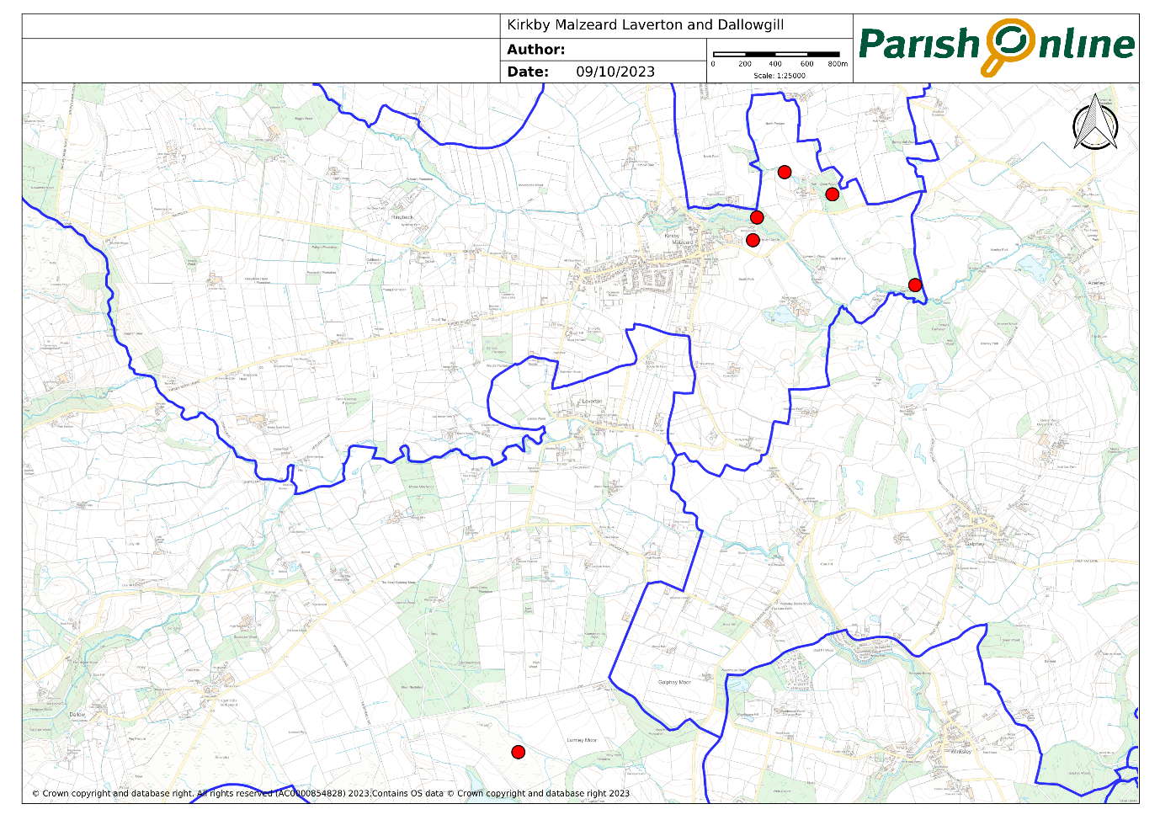
Please use the link in Paragraph 39 below to inspect this map and other NEYEDC documents in more detail.

- These habitats and sites provide an important haven for wildlife. Some of the wide and diverse range of species found in the parish include flowers and ferns such as bluebell, marsh pennywort, wood sorrel and lady-fern as well as rare and declining birds, insects and animals such as the swift, swallow, curlew, tawny owl, hedgehog, adder, hares and bats. Of the larger animals, badgers and deer are common. Wildlife lists for the parish prepared by the NEYEDC and others bear this out. Further information about the wide and diverse range of wildlife can be found in the Neighbourhood Plan pages of the Parish Council website

- The consultation undertaken in the development of the Plan has demonstrated community support for the protection and enhancement of the biodiversity of the parish. This is for a variety of reasons, including supporting wildlife and wildflowers and improving resilience to climate change.

- Net Biodiversity Gain (‘NBG’) is a relatively new national approach to development which aims to leave natural environment in a measurably better state than before it was involved in development. The 2021 Environment Act introduces a mandatory requirement for NBG in the planning system, to ensure that new developments enhance biodiversity and create new green spaces for local communities to enjoy.

- The Government’s Department for Environment, Food and Rural Affairs (DEFRA) has produced a ‘Biodiversity Metric’ to provide a way of measuring and accounting for biodiversity losses and gains resulting from development or land management change. Examples of appropriate methods to address NBG might include:
- Purpose designed boxes and bricks for bats, birds (including owls in remoter areas), bees and other invertebrates, within the structure of the building, or within the site boundaries on non-built features if this is not possible.
- Hedgehog access points in fences.
- Planting new native trees and hedges and flower-rich habitats.
- The intentional use of sustainable drainage systems (‘SUDs).
- ‘Re-wilding’ of areas to support drainage and create habitat.
- Measures to protect the integrity of any affected wildlife corridors, mitigate any harmful impact, and incorporate linkages to provide new connections between corridors.

- The Plan supports these and other methods aimed at enhancing biodiversity. New developments, large and small, should consider how they can contribute to enhancing biodiversity.

POLICY KMLD10: PROTECTING AND ENHANCING BIODIVERSITY
The biodiversity of the parish, including locally important sites of nature conservation, should be protected and enhanced to achieve an overall net gain in biodiversity.

Protecting and Enhancing Trees, Hedgerows and Woodlands

- The parish has many trees and hedgerows, which add greatly to its character and appearance as well as providing a valuable habitat for wildlife and wildflowers.

- Their importance is reflected in the findings of community consultation as well as important studies. When asked ‘Do you feel that additional controls should be included in the Neighbourhood Plan and if so which are the priorities? – tick all boxes you consider important’ (Q.14) in the community survey, preserve existing woodlands and trees and hedgerows and promoting further planting were mentioned most with 88% (or 362) of respondents (for both) identifying them as a priority.

- Much of the parish falls within Kirkby Malzeard and Grewelthorpe Local Character Area. This identifies one of the main characteristics of the Landscape as ‘Tree cover is of deciduous clumps of woodland plus lots of individual trees scattered along field boundaries (sycamore and ash dominate)’. Adding ‘Hedgerow trees are important to diversity, and filter views’ and promoting ‘the planting and replacement of native hedgerow trees (e.g. oak and ash)’. The Kirkby Malzeard Village Design Statement also underlined the importance of trees to the distinct character of the village and the wider parish. It also recommended the use of traditional species in hedging and tree planting.

- The Plan seeks to protect and enhance all important trees, hedgerows and woodlands.

- The trees and woodlands listed below are already protected by the use of Tree Preservation Orders (TPO’s) with 104 in place within the parish as of March 2022. These Orders may be made on individual trees, groups of trees, woodlands or areas containing trees, if it appears beneficial in the interests of ‘amenity’ to do so. The majority of these have been made in large batches, usually on land where development was to take place.

a) REFVAL 95/00010/TPORDR. 9 individual Ash or Sycamore trees within, or on the boundaries of, the development which now comprises St Andrews Meadows and St Andrews Gate, Kirkby Malzeard.
b) REFVAL 15/00034/TPORDR. 61 Individual trees, groups of trees and areas of woodland (mainly comprising Oak, Ash and Sycamores, but with various other varieties) located over a large area to the South and East of Kirkby Malzeard village including The Grange, Back Lane South, South Park and Mowbray Park Farm, Ripon Road.
c) REFVAL 18/00007/TPORDR. 20 individual trees or groups of trees (mainly Ash) situated in, or on the boundary of, land allocated for housing off Laverton Road, Kirkby Malzeard.
d) REFVAL 17/00068/TPORDR. 2 groups of trees and 1 individual tree (Birch, Ash and Sycamore) located at Grey Gables, Laverton Road, Kirkby Malzeard.
e) REFVAL 18/00018/TPORDR. One Redwood and one Sycamore together with a group of 3 Redwoods located at Wensleydale Dairy, Ripon Road, Kirkby Malzeard.
f) REFVAL 20/00039/TPORDR. 3 individual Sycamores on land forming part of, or adjoining New House, Laverton.
g) REFVAL 19/00044/TPORDR. An Area containing trees to the south of Low Keld, Laverton Road, Kirkby Malzeard.
h) REFVAL 06/00022/TPORDR. A group of 6 Sycamores in a field east of Galphay Road, Kirkby Malzeard.
i) REFVAL 92/00011/TPORDR. An Area comprising a line of trees South West of Laverton Bridge, Laverton.
j) REFVAL 06/00022/TPORDR. A Copper Beech at the Old Vicarage, Church Street, Kirkby Malzeard.
k) REFVAL 50/00001/TPORDR. A group of trees near to Holburn Beck, Grantley on the boundary of the Plan Area where it adjoins the neighbouring Grantley, Sawley, Skelding and Eavestone Parish Council area.
To view the location of these, use this link and select the Tree Preservation Orders layer.

- In addition to those trees and woodlands protected by TPOs, all established hedgerows in the countryside are protected through national planning policies. Further clarification is also set out within the countryside hedgerows guidance note (pdf / 553 KB)

- The Parish includes several designated areas of ancient woodland; Mowbray Castle Wood, Wood near Dalton Lodge, North Wood, Carlesmoor Beck Wood and Biggin Wood. Ancient Woodlands have some protection in the planning system. The Plan considers these woodlands to be a key aspect of the Parish’s character and seeks to preserve them.

- Further, Policy NE7: Trees and Woodlands in the Local Plan provides general protection for all trees that have ‘wildlife, landscape, historic, amenity, productive or cultural value or contribute to the character and/or setting of a settlement’.

- However, not all the important trees and woodlands are specifically protected.

- One of the main ways a community can seek to protect important trees is seeking their designation as TPOs. However, legislation does not allow a neighbourhood plan to make a TPO. This would need to be made by the Local Planning Authority. The Plan can, however, highlight the case and local importance for making more TPOs.

PARISH ACTION 3: TREE PRESERVATION ORDERS.
The Parish Council will work in partnership with the Local Planning Authority and other interested parties and individuals to identify and protect trees and woodlands of amenity value in the parish by the use of Tree Preservation Orders.

- Furthermore, the Plan strongly encourages the planting of new trees in the Parish, both to compensate for the loss of existing trees due to disease and natural causes, and to increase the tree coverage of the Parish. The Nidderdale AONB Woodland Opportunity Plan covers all of the Parish and has an objective of increasing tree planting in appropriate areas to improve flood management and extend woodland habitats. The Woodland Opportunity Plan identifies in detail which parts of the Parish are suited to tree planting and which are not. The Plan is supportive of Nidderdale AONB’s efforts, and encourages the planting of broadleaved native species, both those traditional to the local area and those potentially better suited to the future effects of climate change. Such native trees will reinforce the distinctive character of the parish and are better equipped to live with the local climate and soil types, and support food and habitats for wildflowers and wildlife.

https://www.northyorks.gov.uk/sites/default/files/fileroot/planning_migrated/heritage_conservation_areas_and_listed_buildings/9%20Laverton%20Upland%20Fringe.pdf
https://www.northyorks.gov.uk/sites/default/files/fileroot/planning_migrated/heritage_conservation_areas_and_listed_buildings/32%20Skelding%2C%20Galphay%20and%20Lumley%20Moors%20Upland%20Fringe.pdf
https://www.northyorks.gov.uk/sites/default/files/fileroot/planning_migrated/heritage_conservation_areas_and_listed_buildings/34%20Kirkby%20Malzeard%20Parliamentary%20Enclosure.pdf
https://www.northyorks.gov.uk/sites/default/files/fileroot/planning_migrated/heritage_conservation_areas_and_listed_buildings/35%20Kirkby%20Malzeard%20and%20Grewelthorpe.pdf
National Planning Policy Framework - Guidance - GOV.UK (www.gov.uk)
Dark skies - Nidderdale AONB
https://nightblight.cpre.org.uk/maps/
The Institute of Lighting Professionals has produced guidance on acceptable levels of lighting for different areas (environmental zones). These can be found at https://theilp.org.uk/
Priority habitats cover a wide range of semi-natural habitat types that have been identified as being the most threatened and requiring conservation action under the UK Biodiversity Action Plan (BAP)
A SINC is the name given to a Local Wildlife Site in North Yorkshire. Nationally they are more commonly known as Local Wildlife Sites.
https://www.gov.uk/guidance/biodiversity-metric-calculate-the-biodiversity-net-gain-of-a-project-or-development#use-the-metric
https://www.northyorks.gov.uk/sites/default/files/fileroot/planning_migrated/heritage_conservation_areas_and_listed_buildings/35%20Kirkby%20Malzeard%20and%20Grewelthorpe.pdf
https://www.gov.uk/guidance/countryside-hedgerows-regulation-and-management

