KIRKBY MALZEARD, LAVERTON AND DALLOWGILL NEIGHBOURHOOD PLAN

SUMMARY OF DRAFT PLAN – DECEMBER 2023.

This is a summary of the Draft Plan which the Parish Council has prepared in order that the community can have greater influence on Planning application decisions in the local area in the future. Consultation was carried out – a questionnaire was completed by residents with discussions also held with stakeholders (businesses, local groups and organisations etc) – and these responses have now resulted in the Draft Policies and Parish Actions which you see outlined below.

The full version of the Draft Neighbourhood Plan is available on the Parish Council website – if you have time please read the full document as it provides greater background and context for the ‘Policies’ and ‘Parish Actions’ outlined in this summary document.

VISION

To conserve and enhance the character, heritage and identity of the Parish of Kirkby Malzeard, Laverton and Dallowgill, while supporting development that is sustainable and appropriate to the scale and nature of the Parish. Developments should be consistent with delivering a balanced mix of housing, conserving the built heritage and natural rural environment of the Parish, maintaining and improving community facilities, investing in transport and service infrastructure, and enhancing the local economy.

OBJECTIVES

- Housing (Section 5.1)
Balance the competing needs for growth and development with the protection and enhancement of the natural and physical environment. Seek to achieve a housing mix on new developments which reflects the local needs for all age groups with an emphasis on smaller homes suitable for younger people and for those in older age groups who are seeking to down-size.

- Built Heritage (Section 5.2)
To conserve and enhance the rich built heritage of the parish by identifying appropriate buildings and structures as ‘non-designated heritage assets’ and create a ‘Local Area of Special Character and Heritage’ in the centre of Kirkby Malzeard to ensure that this local setting enhances the historic buildings contained within it.

- Natural Environment (Section 5.3)
Enhance and conserve natural habitat whilst at the same time supporting agriculture and encouraging modern diversification. Identify Green Spaces that are important to the community and wildlife and give them further protection against development. Balance recreational use of the countryside with the needs of those who live and work there.

- Community Facilities (Section 5.4)
Ensure that the parish has an extensive and varied range of community facilities including leisure and recreational opportunities, which cater for all age groups. Existing facilities which are viable are to be protected and enhanced with new ones encouraged, where they do not detract from the existing character of the area.

Note: The Neighbourhood Plan is a document for the next decade, so there is no explicit reference to the future of the Henry Jenkins public house, as this is in flux at the moment. However, the plan is supportive of the protection, maintenance and development of community facilities, including public houses.

- Infrastructure (Section 5.5)
Ensure that existing and planned development proposals have suitable and sustainable infrastructure. Work towards the improvement of the transport and service infrastructure of the parish and wider local area.

- Local Economy (Section 5.6)

Ensure that the parish boasts a diverse and extensive array of businesses. Existing viable enterprises should be safeguarded and improved, appropriate farming diversification should be encouraged, and new businesses supported, providing these align with the area’s existing character and AONB designation.

POLICIES AND PARISH ACTIONS (an explanation)

‘Policies’ deal with matters concerning Planning and Development and once the Neighbourhood Plan has been approved, these will be part of the overall framework against which Planning applications are assessed.

‘Parish Actions’ concern other matters which the community considers important, and these will be pursued separately by the Parish Council.

Section 5.1 HOUSING

POLICY KMLD1: KIRKBY MALZEARD DEVELOPMENT LIMITS.

Work on the Plan included consideration of changes to the existing Village Development Limit for Kirkby Malzeard based on consultation with the local community and other stakeholders. These proposed changes are shown on the map below. These proposals should be considered as key input in determining the final boundaries as part of any review undertaken in the future by the local planning authority.

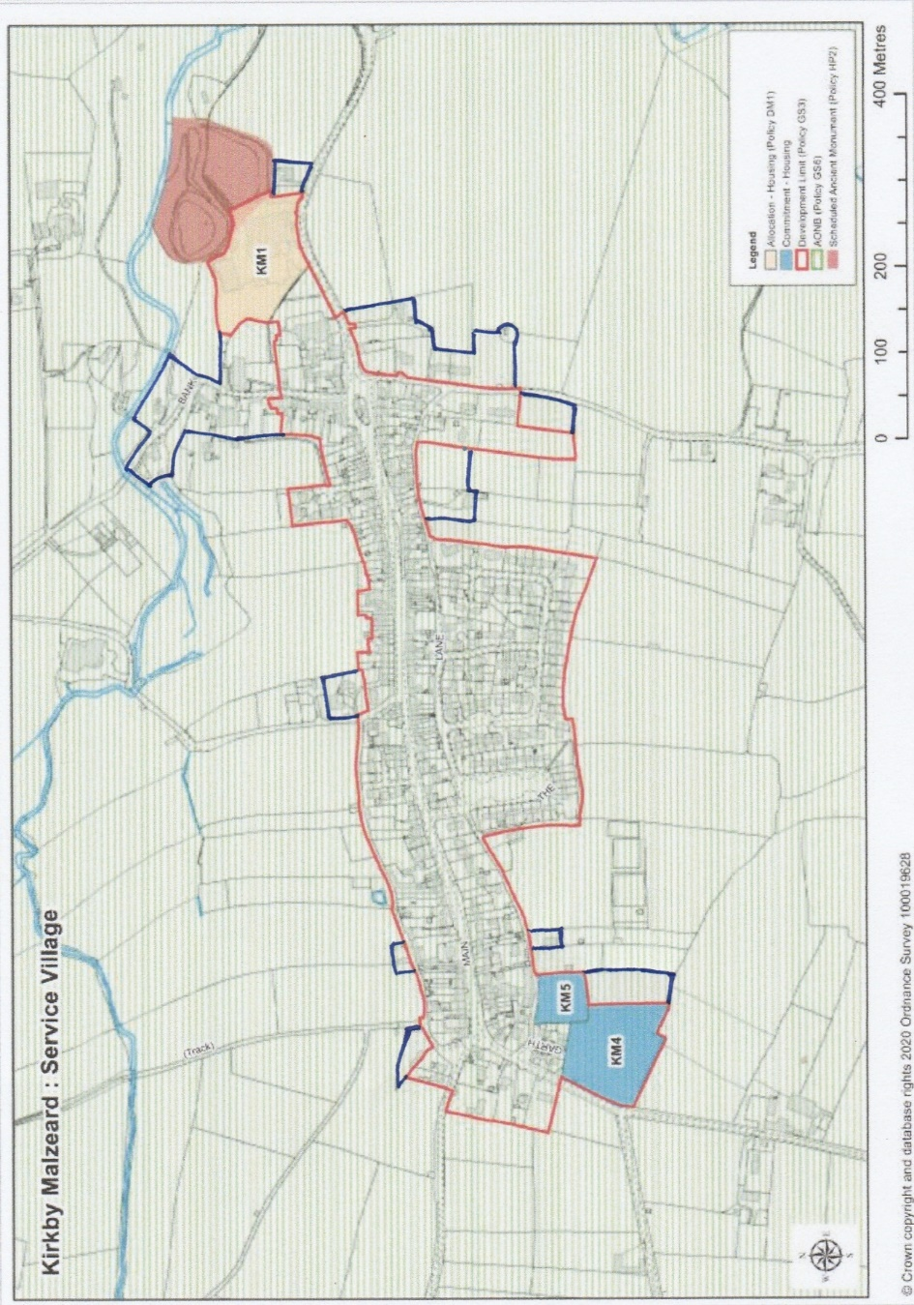

POLICY KMLD2: HOUSING MIX.

To meet the identified need for smaller homes, no more than 50% of new homes in a development of two or more dwellings should have 4 or more bedrooms.

PARISH ACTION 1: AFFORDABLE HOUSING PROVISION.

The Parish Council will monitor the provision of affordable housing on the developments which have been ‘allocated’ or which are ‘commitments’ under the Local Plan. If these prove inadequate to meet the local housing need of the Parish, it will pursue a community-led housing scheme through the means of a Rural Exception site if appropriate.

POLICY KMLD3: PROPERTIES WITH AGRICULTURAL OCCUPANCY RESTRICTIONS.

The Parish Council will not support any applications to remove the occupancy requirements of rural workers dwellings.

POLICY KMLD4: RE-USING REDUNDANT AGRICULTURAL BUILDINGS.

Where planning consent is required for the conversion of redundant traditional barns and other agricultural buildings to form residential units or business premises, such consent would be granted, providing that the new use does not detract from the landscape value of the area and conversion is undertaken in a manner which is sympathetic to surrounding properties.

Section 5.2 BUILT HERITAGE

POLICY KMLD5: NON-DESIGNATED HERITAGE ASSETS

The Plan identifies the non-designated heritage assets listed below and illustrated at Appendix A.
- The Queens Head Public House, Kirkby Malzeard.
- The Ebenezer Methodist Chapel, Kirkby Malzeard.
- Greygarth Methodist Chapel and School Room, Dallowgill.
- The Mechanics Institute, Kirkby Malzeard.
- The Chapel of the Resurrection, Laverton.
- Laverton Bridge.
- Village Pump, Laverton
- Greygarth Monument, Dallowgill.
- St. Peters Church, Dallowgill.
- Dallowgill Bridge.
- Swetton Bridge.
- Stopes Bridge, Dallowgill.
- Aqueduct near Low Ray Carr, Dallowgill.
- Aqueduct across Carlesmoor Beck, Dallowgill.
- Sighting tower at Carlesmoor, Dallowgill.
- The Potato House, Carlesmoor.
Development must conserve these assets and their settings in a manner appropriate to their heritage significance.

POLICY KMLD6: CHURCH STREET KIRKBY MALZEARD LOCAL AREA OF SPECIAL CHARACTER AND HERITAGE
Within the Church Street, Kirkby Malzeard Local Area of Special Character and Heritage as proposed and shown on the Proposals Map and described in Appendix B, development proposals should be of high quality and designed to respect and enhance its distinctive character.

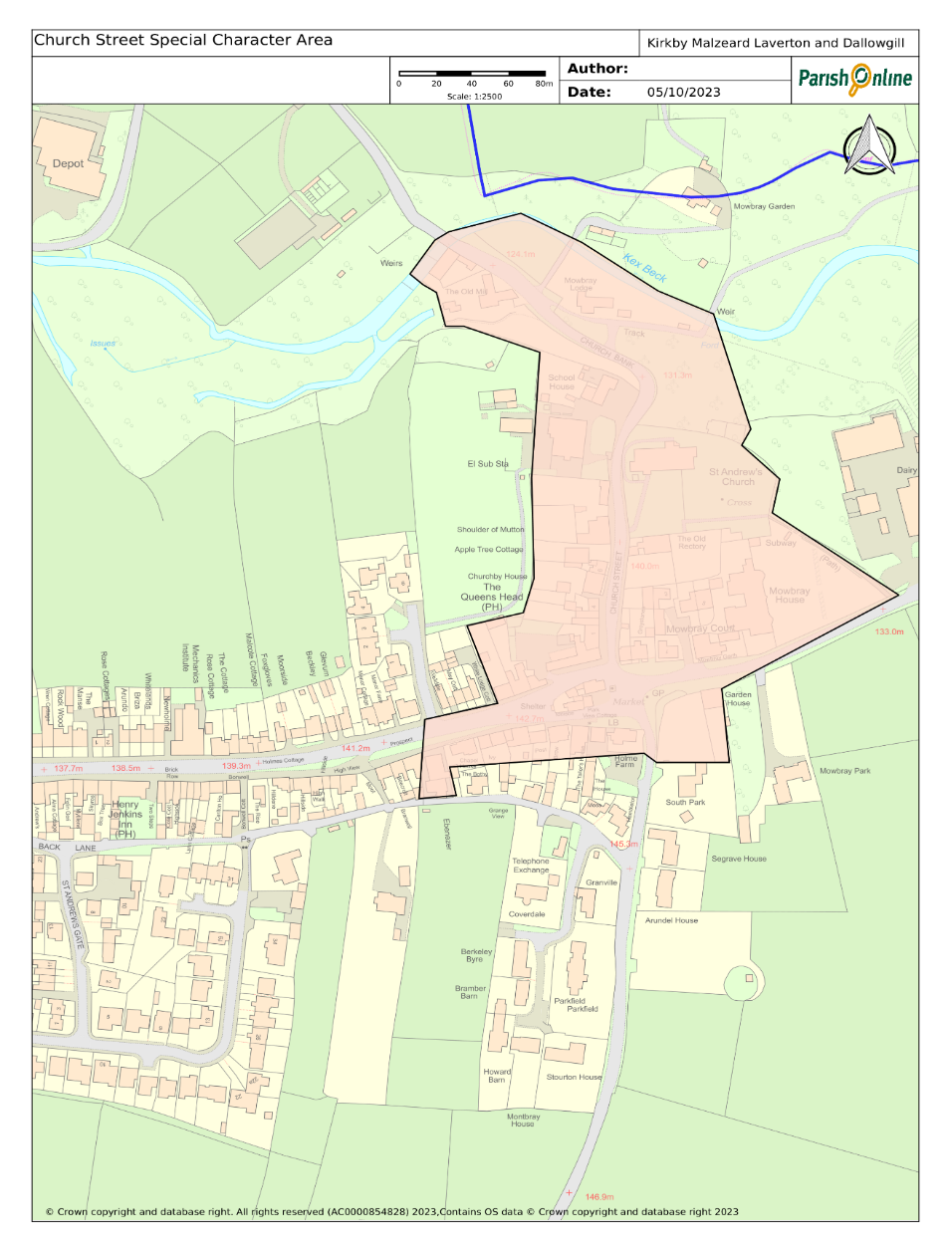

POLICY KMLD7: ENSURING HIGH QUALITY DESIGN.

Development proposals must achieve a high quality of design that respects and where possible enhances the distinctive character of the local area. Development proposals of poor or indifferent design which fail to take the opportunities available for enhancing the local character and sustainability will not be supported. Proposals should be designed in such a way as to meet the following criteria:
a) Reinforce the distinctive qualities of the environment in which it is located, taking account of natural and built character, historical context and established patterns of development.
b) Materials chosen should complement the design of the development and add to the quality or character of the surrounding environment. Elevations to new build properties should be faced with natural stone of the type typical of the area with the appearance of buildings to be inherently traditional.
c) Extensions to existing buildings should follow a design approach that is consistent and in keeping with the building in the use of materials, design and roofline.
d) Good use should be made of site characteristics and surroundings, including: layout and use; and form of space within the site; siting; scale; height; proportions and massing; orientation; architectural detailing; landscape, existing plants, trees and other features and materials;
e) Incorporate adequate landscaping, where practical, to mitigate the visual impact of the development and to ensure that proposals harmonise and merge into the existing rural, village and hamlet context and respond to the wider countryside setting.
f) Protect residential amenity, giving careful consideration to noise, privacy, outlook and to sunlight and daylight.
g) Ensure that the design of roads, parking areas and vehicular access includes adequate provision for road safety and measures to avoid indiscriminate parking by residents and visitors.
h) Positively contribute to mitigation of climate change and meeting climate change targets by:
i. incorporating high standards of energy efficiency and use of renewable energy.
ii. reducing lifecycle carbon emissions through design such as building layout and orientation, choice of materials and construction techniques.
iii. supporting the transition to low carbon or zero emissions forms of transport by measures such as installation of electric vehicle charging points in new dwellings, in public spaces, and in retail or commercial development (see also Policy KMLD15).

Section 5.3 NATURAL ENVIRONMENT

POLICY KMLD8: LOCAL GREEN SPACES.

The sites identified below, and as identified on the proposals map, are designated as Local Green Spaces.
- Highside Playing Fields, Back Lane South, Kirkby Malzeard.
- Jubilee Garden, Main Street, Kirkby Malzeard.
- West End Green, Back Lane North/Ringbeck Road, Kirkby Malzeard
- ‘Island’ of greenspace at the junction of Back Lane North, Ringbeck Road and Main Street, Kirkby Malzeard.
- The Green, Kirkby Malzeard (excluding the section which may be considered for public car park - see Parish Action 5).
- Churchyard surrounding, St Andrew’s Church, Church Street, Kirkby Malzeard.

Development will not be permitted within a designated Local Green Space, unless there are very special circumstances where the public benefits of the development proposed would outweigh the harm that would be caused by development within the Local Green Space.

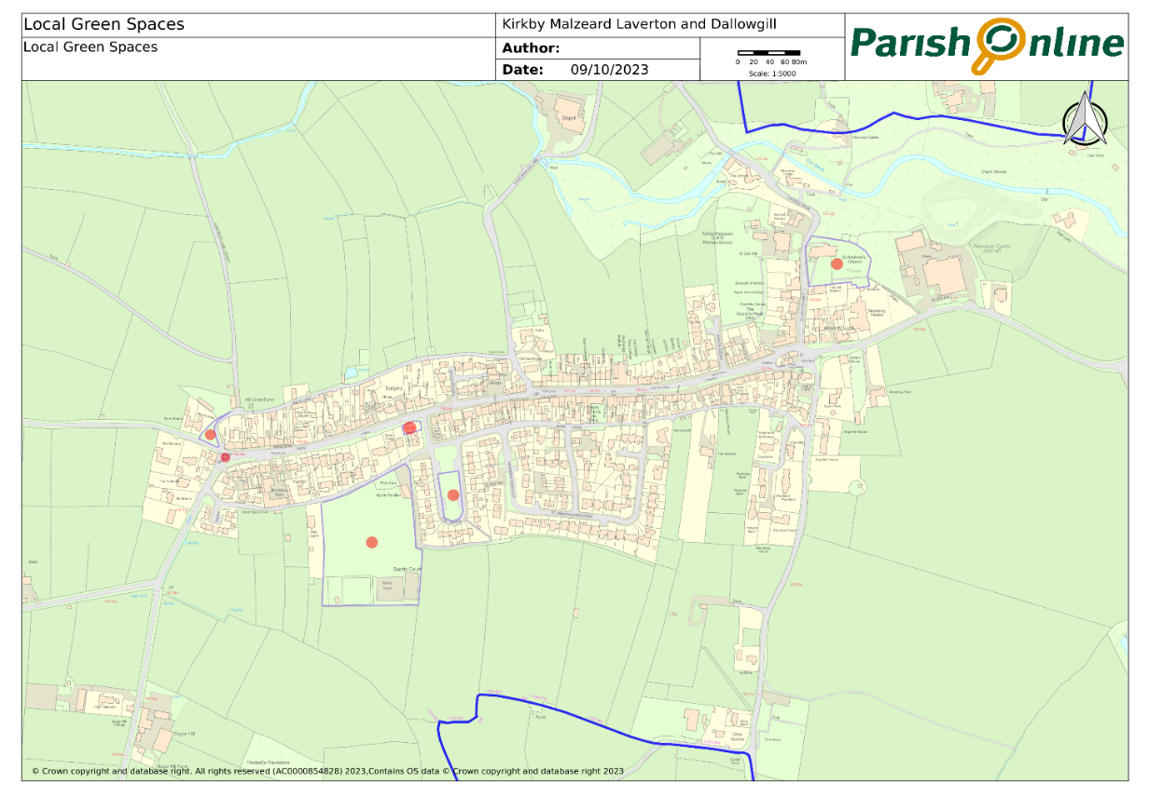

PARISH ACTION 2: ADDITIONAL ALLOTMENT/COMMUNITY GARDEN PROVISION IN KIRKBY MALZEARD

The Parish Council will work in partnership with the Local Planning Authority, local landowners and other interested parties to identify and bring forward an allotment site in or on the edge of Kirkby Malzeard.

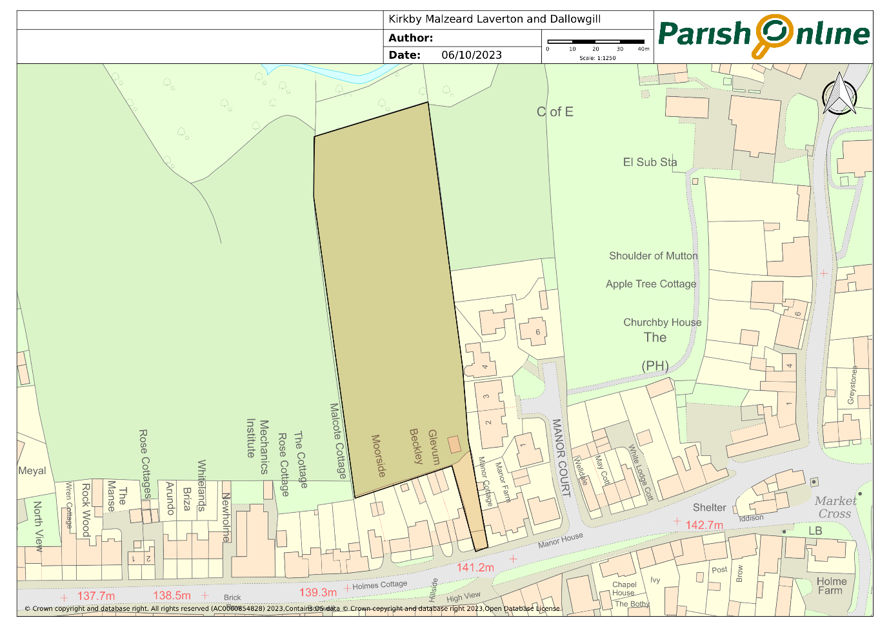

POLICY KLMD9: CONSERVING DARK SKIES

To minimise light pollution and maintain the views of night-time skies, development proposals that include external lighting should demonstrate the following:
- Include only external lighting that is essential;
- Include measures to avoid light spillage beyond the application site; and
- That they meet or exceed the Institute of Lighting Professionals guidance or other relevant current or subsequent standards or guidance.

POLICY KMLD10: PROTECTING AND ENHANCING BIODIVERSITY

The biodiversity of the parish, including locally important sites of nature conservation, should be protected and enhanced to achieve an overall net gain in biodiversity.

PARISH ACTION 3: TREE PRESERVATION ORDERS.

The Parish Council will work in partnership with the Local Planning Authority and other interested parties and individuals to identify and protect trees and woodlands of amenity value in the parish by the use of Tree Preservation Orders.

Section 5.4 COMMUNITY FACILITIES

POLICY KMLD11: ENHANCING THE PROVISION OF IMPORTANT COMMUNITY FACILITIES.

The improvement of existing and the creation of new community facilities (including shops) will be supported, subject to development proposals demonstrating that they respect local character and residential amenity and do not result in harm to highway safety.

POLICY KMLD12: ASSETS OF COMMUNITY VALUE

Development proposals that assist the longevity, appreciation and community value of an Asset of Community Value will be supported and encouraged. Development proposals for a change of use that would result in the loss of an Asset of Community Value will only be supported where it is demonstrated the asset is no longer viable or no longer required by the community; or the asset is replaced by an equivalent or better facility in terms of quantity and quality in an equally suitable location.

Section 5.5 INFRASTRUCTURE

POLICY KMLD13: PROMOTING HIGHWAY SAFETY

To be supported, development proposals must ensure highway safety.

PARISH ACTION 4: HIGHWAY SAFETY.

The Parish Council will work in partnership with the Highway Authority, the Local Planning Authority and other bodies to encourage opportunities to improve highway safety, particularly where the safety of vehicle and vulnerable users has been identified locally as a priority, including Main Street in Kirkby Malzeard.

POLICY KMLD14: CAR PARKING IN KIRKBY MALZEARD.

To be supported, development proposals in Kirkby Malzeard should incorporate sufficient, safe and convenient car parking provision in accordance with the most up to date highway standards.
Development proposals that result in the loss of car parking provision in Kirkby Malzeard will only be supported where:
a) it can be shown that the loss of parking will not have a severe adverse effect on parking provision and road and safety in the nearby area; or
b) adequate and convenient replacement car parking provision can be provided.

PARISH ACTION 5: PROVISION OF PUBLIC CAR PARK IN KIRKBY MALZEARD.

The Parish Council will work in partnership with the Highway Authority, Local Planning Authority and other interested bodies and individuals to explore the feasibility of developing part of ‘The Green’, off Main Street, Kirkby Malzeard to provide a public car park as illustrated by the map above. The provision of publicly accessible charging points for ULEVs will also be considered.

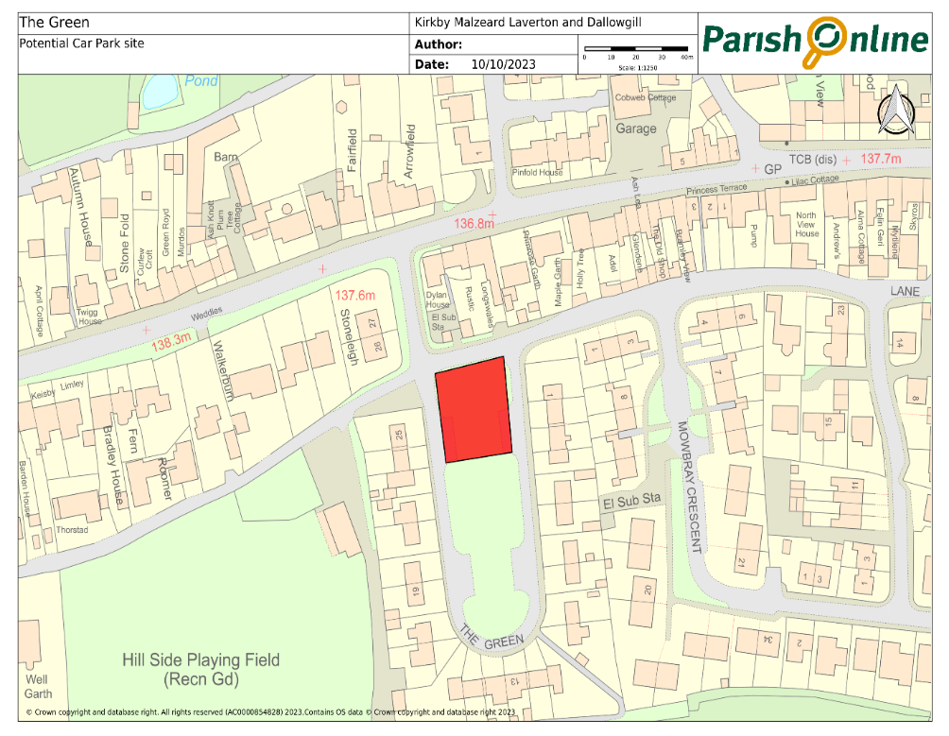

PARISH ACTION 6: LOCAL BUS SERVICES.

The Parish Council will actively lobby the service provider to improve the timetable so that it is better suited to those who might wish to use it. They will also make enquiries to NYC about whether the idea of opening up school buses to other paying passengers is feasible and will continue to promote and publicise services through its website and Facebook pages.

POLICY KMLD15: ULTRA-LOW EMISSIONS VEHICLE INFRASTRUCTURE

Development proposals that include the provision of Ultra-Low Emission Vehicle charging points (public and private) will be encouraged and supported.

PARISH ACTION 7 – PUBLIC ACCESS ROUTES

The Parish Council, in conjunction with residents, local walking groups, cyclists and riders, will take active steps to promote existing routes which could be more extensively used by a larger number of people without causing any detrimental side effects. This could include the publication of guides and the maintenance of signs, stiles, gates etc. in conjunction with landowners and NYC Countrywide Access Services. It will also investigate alongside other interested parties as to what scope exists to extend the local network further.

PARISH ACTION 8: UTILITIES

The Parish Council will seek to ensure that whenever any major development (ten or more houses) is proposed that Utility Companies and Agencies are fully responsible for any essential upgrading work to services and that this is undertaken prior to the development being completed, with a delivery plan for how utilities should be upgraded and installed approved before development commences.

Section 5.6 LOCAL ECONOMY

POLICY KLMD16: SUPPORTING THE DEVELOPMENT OF THE LOCAL ECONOMY.

Though some types of development do not necessarily need planning permission, where it is required, the Plan is supportive of new commercial and business development, providing it both supports local employment and can be undertaken sympathetically and without significant adverse impacts upon the quality of the local character and amenity, neighbouring uses and highway safety.

