KIRKBY MALZEARD LAVERTON AND DALLOWGILL NEIGHBOURHOOD PLAN

APPENDIX B

MARKET CROSS/CHURCH STREET/CHURCH BANK LOCAL AREA OF SPECIAL CHARACTER AND HERITAGE

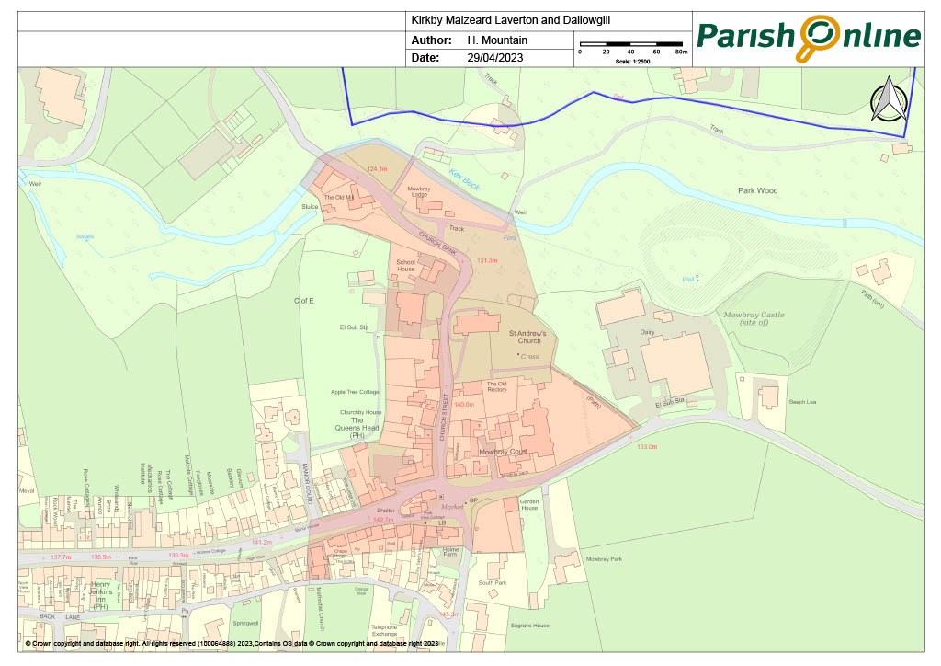

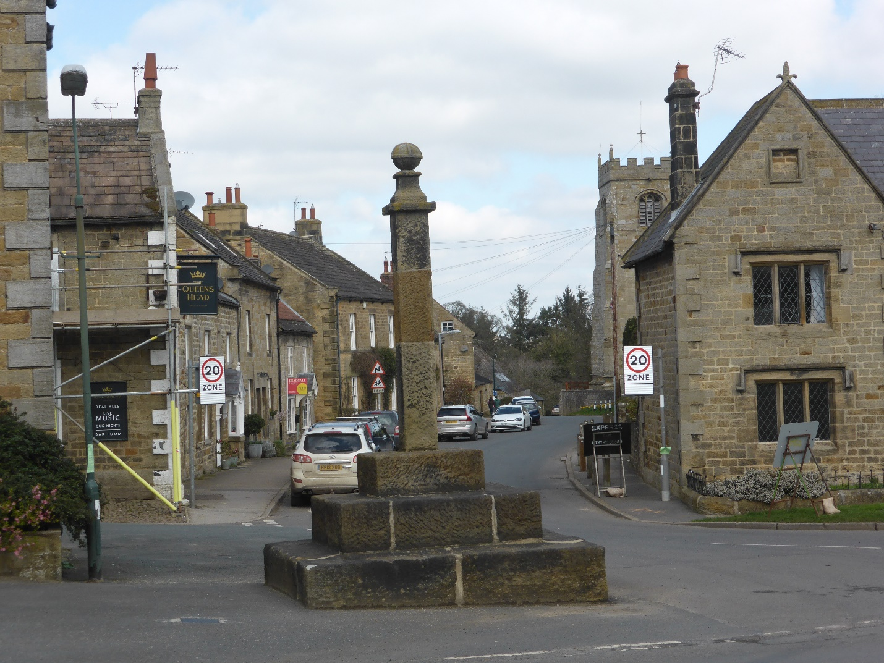

GENERAL DESCRIPTION

The area around the Market Cross (extending North along Church Street and down Church Bank, and East/West along Main Street and Ripon Road), was the historic heart of the Kirkby Malzeard and is still the centre of the modern-day village.

In addition to the Grade I Listed Church, the prominent Market Cross and a number of other Listed buildings and structures, the area currently incorporates the local Primary School, the village General Stores, the one remaining public house in the Neighbourhood Area and until recently the Methodist Chapel, although this closed in 2023.

SETTING

Whilst Kirkby Malzeard is essentially of linear design, in this part of the village the east/west village Main Street, which eventually leads to Ripon, crosses a north/south road leading to Masham and the Dales (to the north) and Harrogate and the West Riding (to the south). For most visitors therefore, both at present and in the past, this is first part of the village which they encounter.

The buildings within this Area of Special Character and Heritage date almost exclusively from the 18th and 19th centuries or earlier. There are also some modern buildings forming the current School which were constructed in 1971, used in conjunction with the older buildings dating from 1862, but the over-riding sense is of a long- established village area with its own distinctive nature within the wider village context.

Although the Area is effectively fully developed there are some individual open spaces formed by the residential gardens to the larger houses, with a wooded area alongside Church Bank and adjacent to Kex Beck.

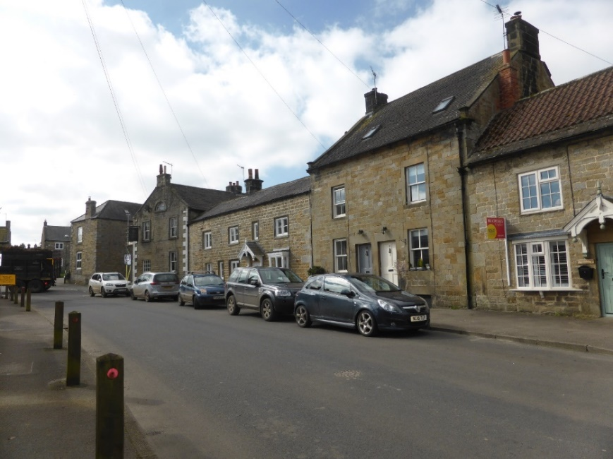

HISTORIC DEVELOPMENT

Mowbray Castle, understood to have been a wooden structure on earthen ramparts (the site of which is now a Scheduled Monument) located approx. x metres to the north-east, would initially have dominated this landscape but after its destruction in 1174, the Church and Market Place became the centre, not only for villagers but of a much wider Parish area, known as the Honour of Kirkby Malzeard, the boundaries of which spread for miles, from as far as Great Whernside to the west and Ripon to the east.

Work to rebuild the existing Church in stone is understood to have commenced circa 1150 and continued over five centuries with various different architectural styles in evidence including Norman, late Perpendicular and Early English. Some of this work still remains today but fire damage occurred in 1876 and again, to a greater extent in 1908, after which major restoration was undertaken.

The current Market Cross, situated at the junction of Church Street, Main Street, Ripon Road and Galphay Road, was erected in 1868 to replace an older Cross, and this carries a plaque commemorating the granting of a Market Charter by King Edward I in 1307.

Given the presence of the Church and the Market in this location it is inevitable that other buildings will have been built and rebuilt here over the centuries with their usage changing to reflect the fortunes of the area. At the present time the buildings are predominantly residential but house names such as ‘The Old Post Office’ and ‘The Tailors House’ indicate that a greater proportion were originally shops, with a former public house (‘The Shoulder of Mutton’) also situated on Church Street. Churchby House situated close by was originally the Doctors Surgery and there was even a Youth Hostel in a metal sheet hut close to the Methodist Chapel on Main Street but this was demolished in recent years and the site redeveloped for housing.

LIVED EXPERIENCE

Positioned as it is, this area incorporates the main access routes into the village and so inevitably there is a significant amount of passing traffic coming and going throughout the day. The presence of the school, village shop and public house also result in some increased pedestrian use at certain times but for the most part Church Street and Church Bank are peaceful areas in which to live.

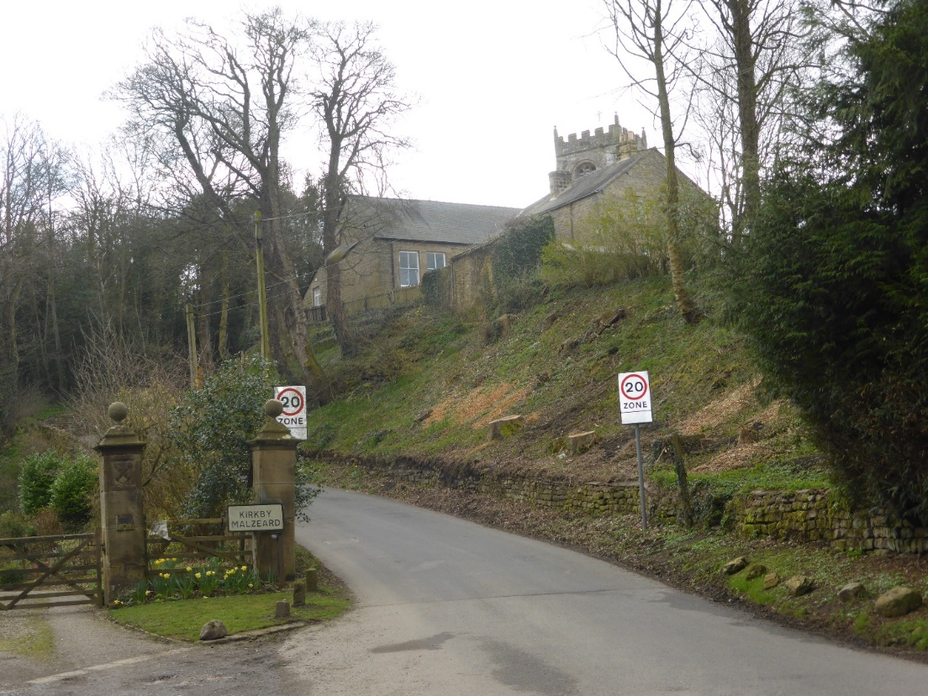

ARCHITECTURAL QUALITY AND BUILT FORM

The majority of buildings within Kirkby Malzeard are built of the local stone, as is the case with those within the Special Character Area. Roof coverings also reflect the remainder of the local area with no particular type of tile or slate being predominant. Traditionally stone slates or even thatching with heather would have used to some houses but blue slates or clay tiles were used more commonly during the nineteenth century.

All of the older buildings are considered to have some individual architectural merit and they combine to create attractive frontages of substance, broken in places by sympathetically positioned climbers and shrubs. Where modern development has taken place, such as within Mowbray Court, the houses have been thoughtfully designed to provide individuality whilst being in sympathy with surrounding buildings.

Objectively whilst the old school buildings are of traditional Victorian appearance the new classrooms added in the 1970’s are lacking by comparison with the design owing more to functionality and cost saving than any attempt to blend in with the spirit of the local area.

OPEN SPACES, GREEN AREAS, PARKS, GARDENS AND TREES.

This is a relatively intensively developed area of the village with only limited open spaces or green areas and whilst some of the larger residential properties have correspondingly well-proportioned gardens, the majority have outside spaces of a limited nature. The gardens to Mowbray House and the Old Vicarage incorporate some mature trees including an oak (?) to the latter which is covered by a TPO.

The redundant Churchyard is however a valuable Green Area which as well as providing an attractive setting for the Church itself also is sympathetically maintained in a way which allows some wild flowers and wild life to flourish.

The section of the area at the bottom of Church Bank is more open with mature trees and grassed areas adjacent to Kex Beck, giving this northern part of the Special Character area a rural ‘edge of village’ nature.

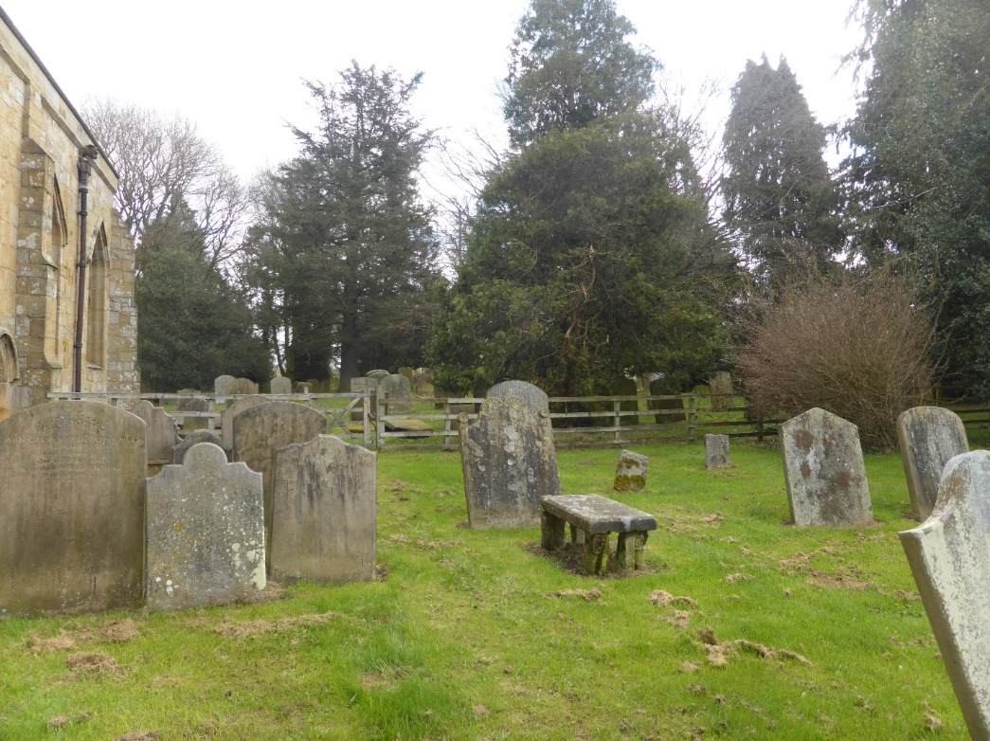

DESIGNATED AND NON-DESIGNATED HERITAGE ASSETS

In addition to St Andrews Church and the Market Cross referred to above there are a relatively large number of other Listed Buildings and Structures contained within the boundaries of this compact area.

The Old Rectory adjacent to the Church dates from 1813 being of stone construction under a slate covered hipped roof. The Shoulder of Mutton, on the opposite side of Church Street, is understood to date form the 17th century, whilst Churchby House and the attached Churchby Cottage also face east on Church Street and date from the 18th century, as does No 1 Church Street which incorporates a datestone from 1723.

There are also 2 Table tombs in the Churchyard which are Listed being those of William and Helen Hobbs from 1674 and George Hewitt from 1739, together with the tombstone of Rev. Peter Save from 1732. A medieval Cross also stands in the Churchyard which is believed to be a preaching Cross.

Barkways and Greystones, a pair of semi-detached houses front onto Ripon Road having being originally constructed as Almhouses in 1848, with Mowbray House, which is a substantial stone-built house built in 1812 with Victorian additions.

The Area also includes a number of other significant properties such as the Queens Head public house which dates from the 18th Century and is one of the Non-Designated Heritage Assets referred to in Section xx . The Mill and The Old Mill at the northern end of Church Bank are also noteworthy due to their nature and history.

