APPENDIX A

NON-DESIGNATED HERITAGE ASSETS
POLICY KMLD5

POLICY KMLD5: NON-DESIGNATED HERITAGE ASSETS

The Plan identifies the non-designated heritage assets listed below and illustrated at Appendix A.
- The Queens Head Public House, Kirkby Malzeard.
- The Ebenezer Methodist Chapel, Kirkby Malzeard.
- Greygarth Methodist Chapel and School Room, Dallowgill.
- The Mechanics Institute, Kirkby Malzeard.
- The Chapel of the Resurrection, Laverton.
- Laverton Bridge.
- Village Pump, Laverton
- Greygarth Monument, Dallowgill.
- St. Peters Church, Dallowgill.
- Dallowgill Bridge.
- Swetton Bridge.
- Stopes Bridge, Dallowgill.
- Aqueduct near Low Ray Carr, Dallowgill.
- Aqueduct across Carlesmoor Beck, Dallowgill.
- Sighting tower at Carlesmoor, Dallowgill.
- The Potato House, Carlesmoor.

Development must conserve these assets and their settings in a manner appropriate to their heritage significance.

1
Name: The Queens Head Public House, Kirkby Malzeard.
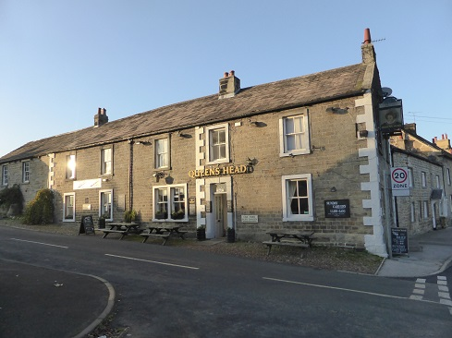

Location: Situated overlooking the Market Cross on the junction of Main Street/Ripon Road (running East/West) and Church Street/Galphay Road (running North/South) being the historic centre of Kirkby Malzeard (see Church Street Area of Special Character and Heritage).
Grid Reference: 423501 474408
Description: Two storey building of stone construction under stone slate roof forming public house with ancillary accommodation.
History: This public house dates from the 19th century when it was one of a number of public houses in the village. In its early years prior to the creation of the Mechanics Institute it served as the principal venue for public events such as auctions, hearings etc.
Reason for inclusion: Being the last functioning public house with the Plan Area with a long unbroken tradition of serving the local community, it is seen as important that it is given added protection.

2
Name: The Ebenezer Methodist Chapel, Kirkby Malzeard
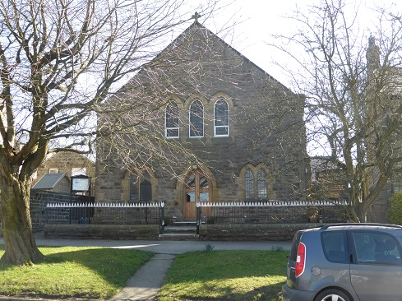
Location: Situated on the South side of Main Street towards the eastern end of Kirkby Malzeard
Grid Reference: 423419 474361
Description: Stone built building of two storey height having a slate covered roof with small single storey side extension.
History: Constructed in 1880 – 1881 to replace a smaller building nearby which now forms a private house. Ebenezer (meaning ‘stone of help’) Chapels were created nationally following the secession in 1797 by a group subsequently known as the New Connexion Methodists from the Wesleyan Methodists. There was also a Primitive Methodist Chapel in the village and another Chapel in Laverton (built in 1895) both of which are now private houses. The Ebenezer Chapel continued to function as a Chapel until 2022 and currently stands empty until a new use can be found.
Reason for inclusion: Symbolic reminder of a once important form of Christian worship in the Kirkby Malzeard area.

3
Name: Greygarth Methodist Chapel, Dallowgill

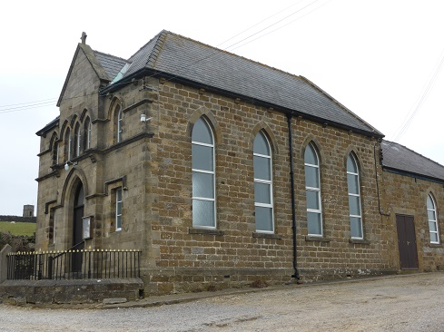
Location: Situated within the hamlet of Greygarth which forms part of Dallowgill. The Chapel is situated just below Greygarth Monument (asset 1).
Grid Reference: 418770 472316
Description: 19th century Methodist Chapel of Gothic design.
History: The existing Chapel replaced a smaller chapel just to the south west which had been built in 1816. Land to build a new Chapel was bought from the Marquis of Ripon and the original chapel demolished. This new Chapel was built by Brothertons (builders of Kirkby Malzeard) at a cost of £263 with the foundation stone laid on 12 June 1885. The first service was on 19th October of the same year. The school room was added in 1930 and the small adjacent car park formed to the side in 1953. Regular services are still held here.
Reason for inclusion: Prominent Victorian building of importance to the local community.

4.
Name: The Mechanics Institute Village Hall, Kirkby Malzeard.
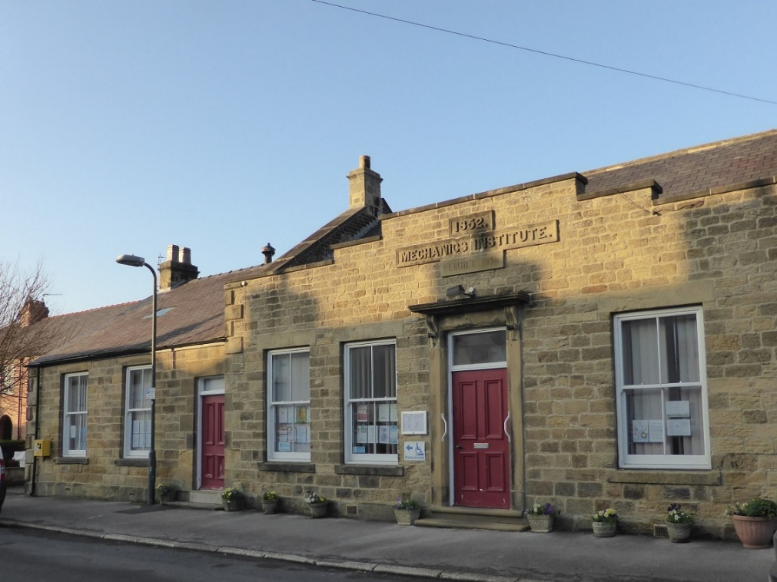
Location: Situated in the centre of Kirkby Malzeard village fronting onto Main Street.
Grid Reference: 423286474361
Description: Detached single story building of stone construction with slate covered roof comprising main hall and ancillary accommodation.
History: The building formerly known simply as ‘The Mechanics Institute’ was established and built as a two-storey building in 1852 as part of the Victorian Education and Training initiative. In 1936 following structural problems much of the building was demolished and rebuilt as a single storey building with a large hall added. It was further extended in 2002 by adding a side annex.
Reason for inclusion: Important community building with historic connections.

5.
Name: Chapel of the Resurrection, Laverton
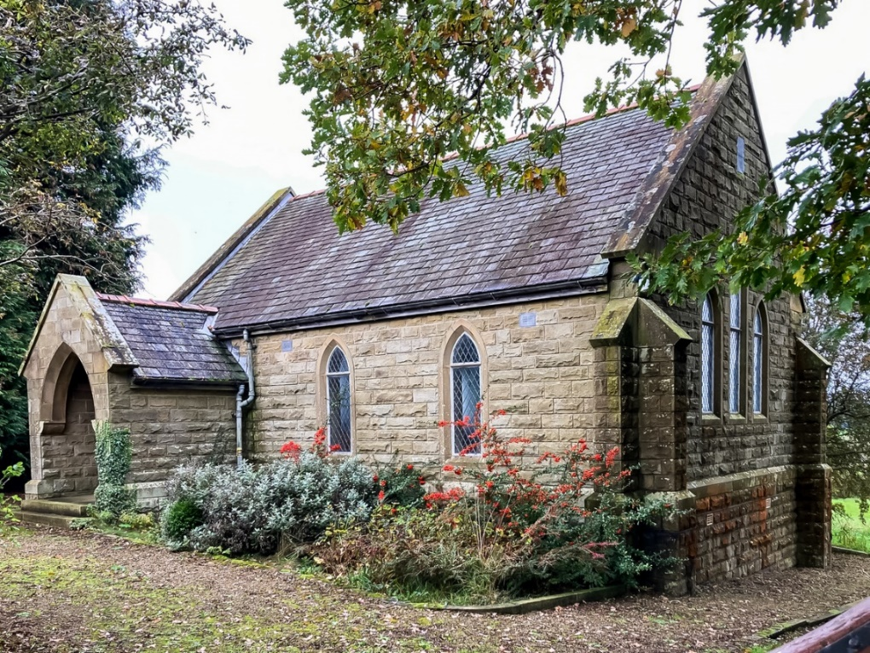
Location: Situated alongside the Laverton to Pateley Bridge road approx. 1 mile south east of Laverton. Land originally formed part of Mossie Mire Farm.
Grid Reference: 421568 472394
Description: Small Church of England Chapel with open churchyard.
History: Opened following the closure of the churchyard at St Peters Dallowgill. Dedicated on 24 March 1956. The building is still used for monthly services during the summer months.
Reason for inclusion: The building is the sole place of Anglican worship in the Parish of Laverton and the sole burial site serving all denominations.

6.
Name: Laverton Bridge and Pinfold.
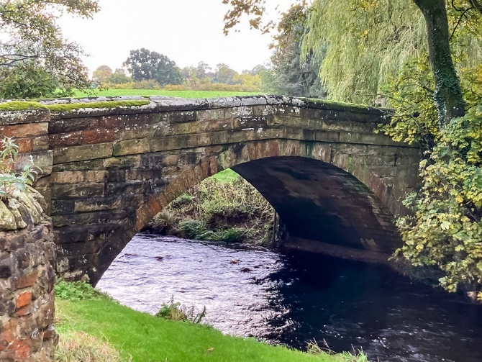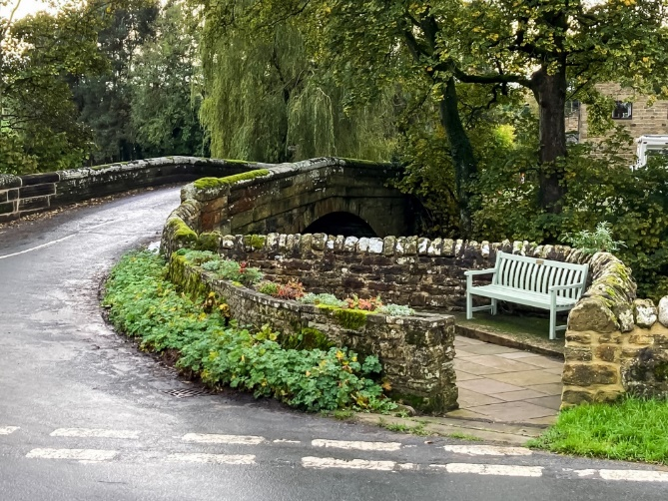
Location: Situated in the centre of Laverton village, being the second largest community in the Parish.
Grid Reference: 422804 473294
Description: Single arch stone bridge crossing the River Laver. It carries the single carriageway road between Kirkby Malzeard and areas to the south. The small historic pinfold is immediately adjacent and now provides a seating area. The bridge is owned by, and is the responsibility of, North Yorkshire Council. The ownership of the Pinfold is unknown.
History: Bridge originally built in 1813 but largely rebuilt in 1923 following partial structural collapse. It is understood that copies of newspaper and coins of the time were buried within the structure. The Pinfold is older but has been remodelled to accommodate road re-alignment.
Reason for inclusion: Principle architectural structure and focal point in Laverton. It is located in the centre of the village and connects both sides of the village being the only river crossing. The Pinfold provides a central meeting/seating point for villagers with floral borders maintained and cared for by local residents.

7
Name: Laverton Village Pump
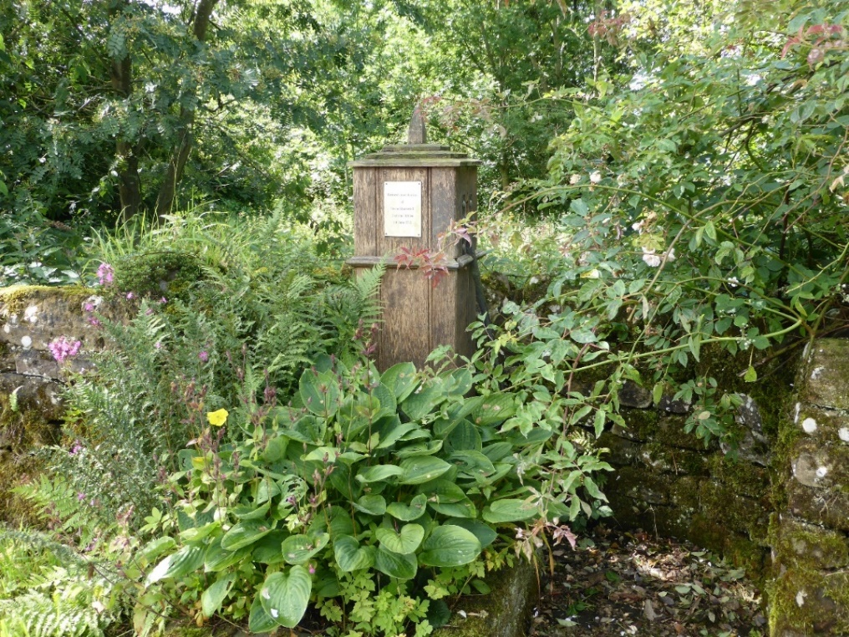
Location: Centre of Laverton village close to the bridge and pinfold (asset 6)
Grid Reference: 422832 473295
Description: Redundant water pump with stone trough refurbished as village feature.
History: The pump was originally constructed in 1854 and served the villagers up until as recently as 1960 when a temporary bore hole supply was created until mains water was connected to the village in 1963. The pump was then renovated as a decorative feature.
Reason for inclusion: Interesting item of Victorian ‘street furniture’ which once played an important role in villagers’ lives.

8
Name: Greygarth Monument, Dallowgill
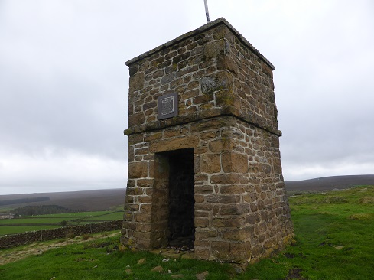
Location: Situated in the hamlet of Greygarth within Dallowgill
Grid reference: 418618 472363
Description: Square stone-built tower extending to approximately 5m in height located on high ground to the west of the hamlet of Greygarth. An internal ladder provides access to a small viewing platform giving panoramic views over the countryside beyond. It is approached solely by a permissive footpath across agricultural land.
History: The present tower is understood to be constructed on the site of earlier towers with the original built sometime in the mid-18th century, on the site where, so the story goes, the last wolf in Dallowgill was killed. That tower is understood to have been ‘tall and pointed’ but it was blown down by gales and a smaller tower replaced it 1897 marking Queen Victoria’s diamond jubilee. The condition of this replacement tower deteriorated over time and in 1984 the Parish Council restored it in its present form. It is owned by the Parish Council who are responsible for its insurance and maintenance.
Reason for inclusion: Prominent historic local landmark often used as the visual symbol of Dallowgill.

9.
Name: St Peters Church, Dallowgill
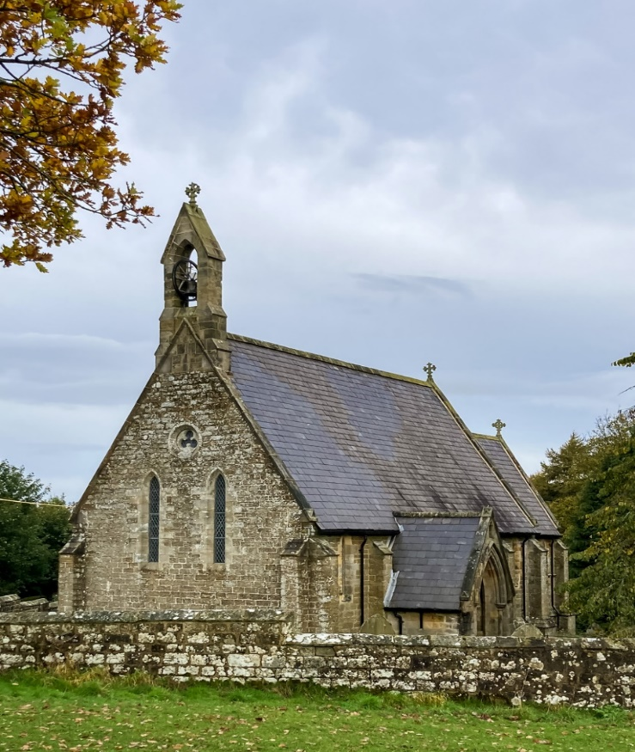
Location:
One of a small group of properties situated alongside the principal road around Dallowgill. Due to the nature/use of the properties this was generally seen as the centre of Dallowgill during the 20th century. In addition to the Church there was a Vicarage, School and Post Office (being part of Knott Farm) all close by.

Grid Reference: 419469 471809
Description: Redundant Anglican Church in the Early English style with closed churchyard.
History: Built by John Brotherton (builder of Kirkby Malzeard) to the designs of A H Cates at a cost of £450. Consecrated 17 October 1842. Original stone alter removed soon after construction as the Lord Bishop of Ripon said to have disapproved of it. This then stood in the churchyard until finally disposed of in 1980. The churchyard was closed in 1956 and the church itself closed for services in 2011. It has recently been converted to serve as an ancillary building to the neighbouring Outdoor Education Centre (former School).
Reason for inclusion: Locally important building.

10.
Name: Ladyhill (Dallowgill) Bridge
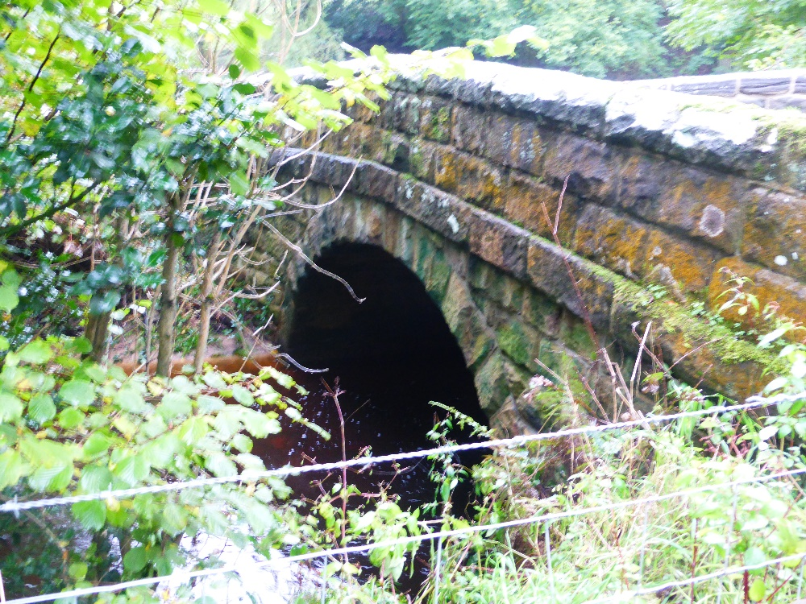
Location: Situated in the Ladyhill/Belford area of Dallowgill
Grid reference: 420321 472210
Description: Stone-built singe arch bridge crossing the River Laver. It carries the single carriage way road linking Dallowgill to Laverton and Pateley Bridge. It is owned by, and is the responsibility of, North Yorkshire Council.
History: Understood to have been built in 1862 having been commissioned by the local landowner Lord Ripon to replace the original ford.
Reason for inclusion: Historic bridge which still has importance for present day residents in providing access between communities within the Parish.

11.
Name: Swetton Bridge, Dallowgill
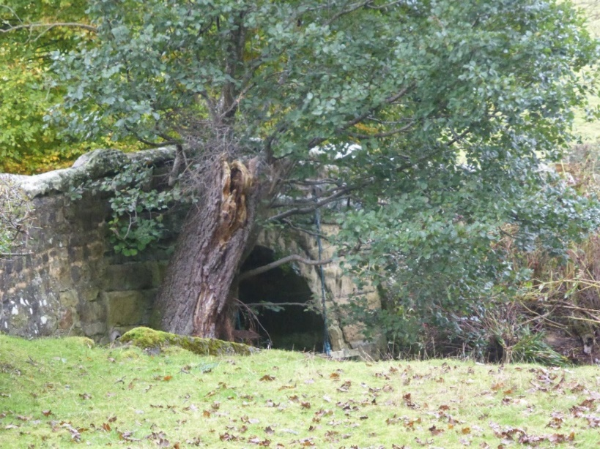
Location: Situated within open countryside in the Swetton area of Dallowgill.
Grid Reference: 420081 473487
Description: Single arch stone-built bridge crossing one of the tributaries of Carlesmoor Beck. It carries the single carriage road linking Dallowgill and Kirkby Malzeard. It is owned by, and is the responsibility of, North Yorkshire Council.
History: The bridge was constructed in 1853 to replace a ford. It was commissioned by the landowner John Morritt Esq and was constructed by Thomas Hall, a Builder from Kirkby Malzeard. Work was required to raise the height of the road in the 1920’s after the first motor bus got stuck on the hump of the bridge.
Reason for Inclusion: Historic bridge which still has importance for present day residents in providing access between communities within the Parish.

12
Name: Stope Bridge, Dallowgill
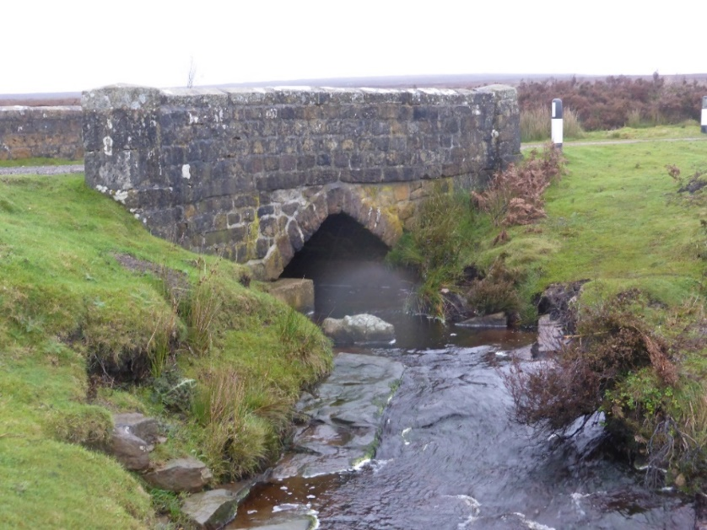
Location: Moorland to the west of Tom Corner, Dallowgill
Grid reference: 416001 472947
Description: Stone single arch bridge carrying a single unmade track over North Gill Beck. It is owned by, and is the responsibility of, North Yorkshire Council. The track is little used except by gamekeepers maintaining the moors, and by walkers. It offers open views to the east towards the North Yorkshire Moors, Teesside, and York.
History: The track which this bridge carries was originally a packhorse/cart track created for the monks of Byland Abbey near Thirsk, to access land near Bouthwaite in Nidderdale. There was originally a ford known as Stope Wath in this location with the present bridge built by John W Hall of Kirkby Malzeard in approximately 1890 at a cost of £5. The bridge was badly damaged by a storm in 1908 and required substantial repair.
Reason for inclusion: There are only a limited number of structures on Dallowgill Moor. The beck crossing has historic significance dating back to the Middle ages and the bridge is well loved by locals due to the long distant views to the east.

13.
Name: Belford Aqueduct, Dallowgill
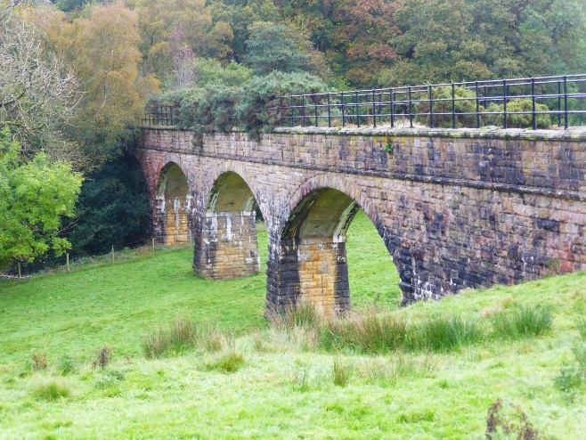
Location: Situated in open farmland to the west of Belford Lane. The aqueduct crosses the River Laver.
Grid Reference: 420725 472585
Description: Stone built three arch structure approx. 10m high housing a water supply pipe.
History: This structure was built in conjunction with the construction of Roundhill Reservoir between 1903 and 1911.
Reason for inclusion: This aqueduct, together with a similar structure further to the north (asset 14) and the Sighting Tower (asset 15) are unusual structures with all three being individual and prominent.

14
Name: Carlesmoor Aqueduct, Dallowgill
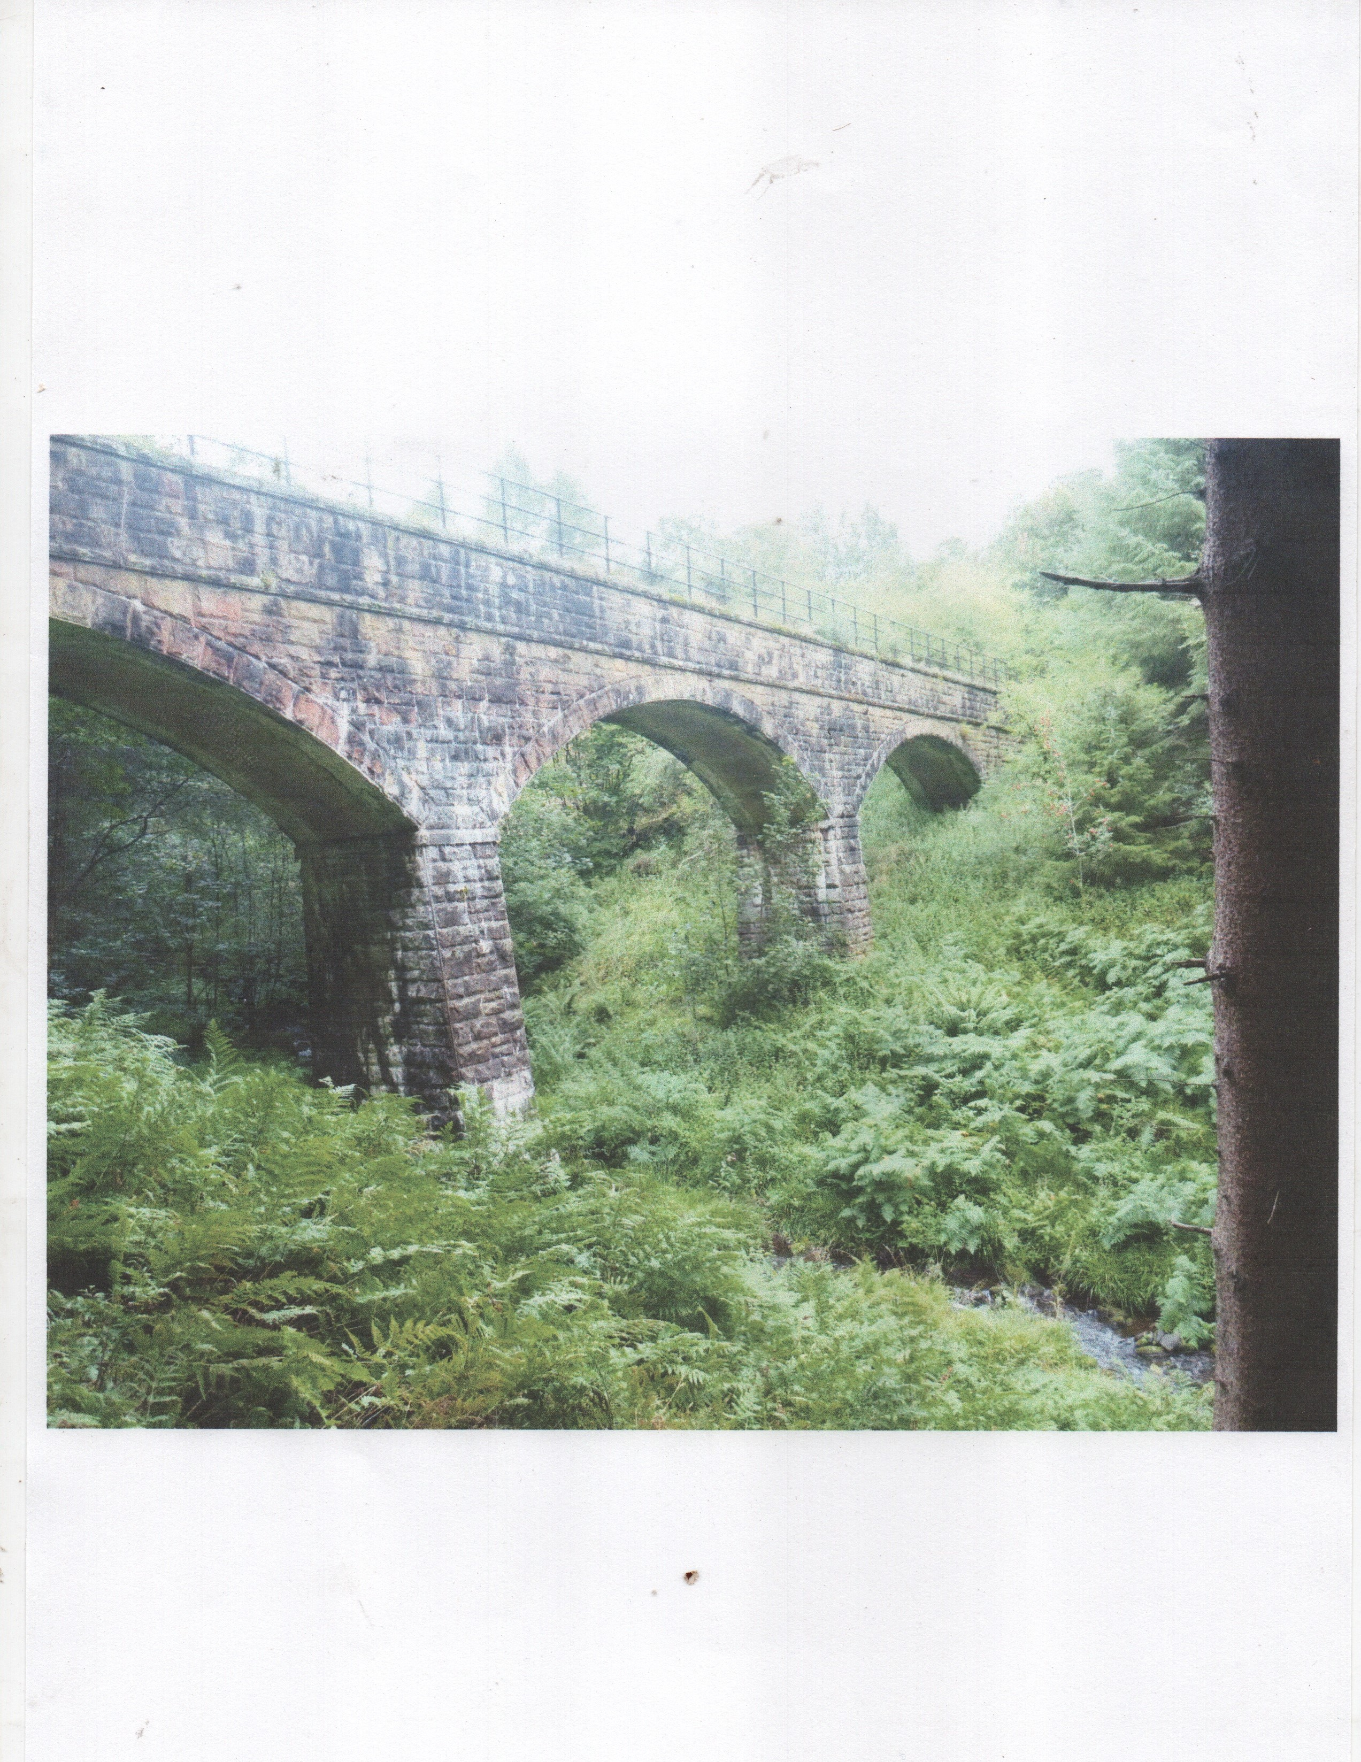
Location: Situated in Carlesmoor valley south of Low Farm. The aqueduct crosses Carlesmoor Beck.
Grid Reference: 419560 473469
Description: Stone built three arch structure approx. 12m high housing a water supply pipe.
History: This structure was built in conjunction with the construction of Roundhill Reservoir between 1903 and 1911.
Reason for inclusion: This aqueduct together with a similar structure further to the south (asset 13) and the Sighting Tower (asset 15) are unusual structures of a type not commonly found in the countryside with all three being individual and prominent.

15.
Name: Carlesmoor Sighting Tower, Dallowgill
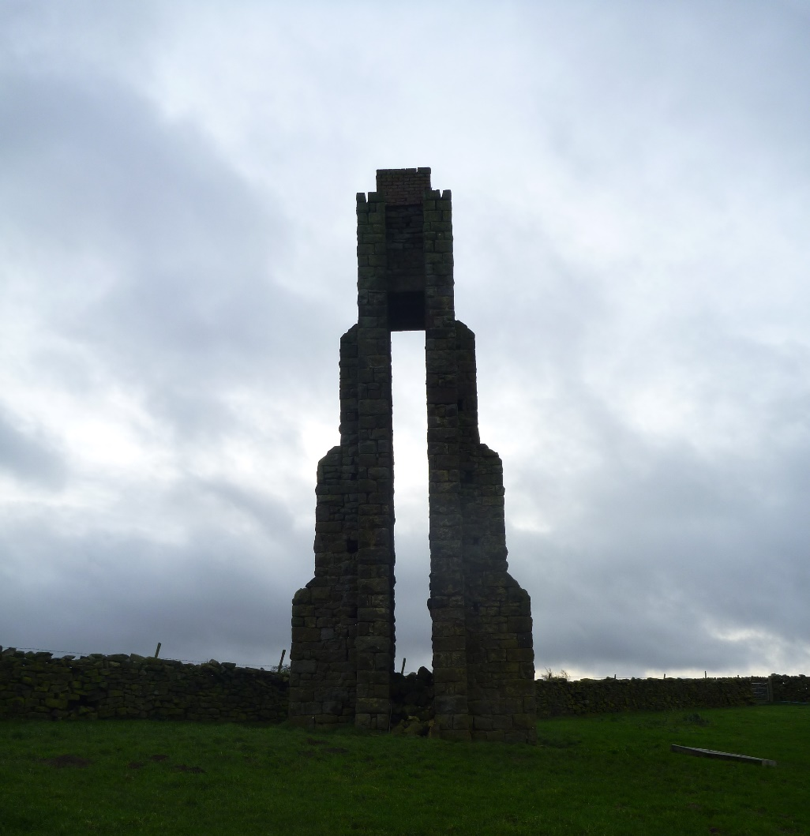
Location: To north of Low Farm, Carlesmoor Lane, Dallowgill
Grid Reference: 419480 473707
Description: Stone built Sighting Tower situated in open farmland having a height of approx. 10m.
History: It was built in conjunction with the construction of Roundhill reservoir (approx. 4 miles NW of the Parish) between 1903 and 1911, being one of three towers used to triangulate the end of the water tunnel for the pipeline towards Harrogate.
Reason for inclusion: Notable local landmark of historic interest. Similar tower close to Roundhill Reservoir is Grade II listed.

16.
Name: Potato House, The Grange, Carlesmoor, Dallowgill.
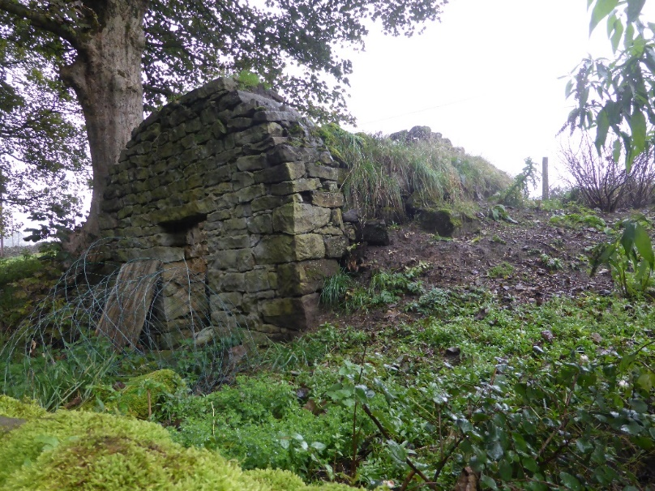
Location: This structure is located adjacent to Carlsmoor Lane within the grounds of a farmyard.
Grid Reference: 419315 473504
Description: Small structure approx. 2m x 6m with arched roof having height of approx. 2m being of stone construction built into the slope of the land. The roof would originally have been sealed with clay and covered with soil or turfs to make water tight. Door opening to front and normally having opening to rear to enable potatoes to be shovelled in.
History: Understood to be of Victorian origin.
Reason for inclusion: The structure is now relatively rare and due to its position is readily visible from Carlesmoor Lane which is a well used public bridleway/footpath. The main farm house is Grade II Listed but there is no reference to this outbuilding within the Listing Entry. The structure is now becoming derelict and it is hoped that inclusion as a non-designated heritage asset will provide some protection against further decay and encourage the provision of funding towards the cost of renovation work.

